 | VIỆN ĐÀO TẠO QUỐC TẾ FPT  DATA SCIENCE WITH AI-ML |         

AI Job Market Salary Prediction
Technical Specification Design - Semester II
Lecturer: Ms. Nguyen Ha Vy
Course: I1.2510.E0
Group: 03
Member: | Full Name |  | Student ID
 | 1. | Huynh Minh
 | 2. | Ta Gia Hien
 | 3. | Gia Bao
 | 4. | Nguyen Kim Ngan | FIS00016
- September 2026 -

TABLE OF CONTENTS
A - PROJECT INTRODUCTION 2
A.1. Project Scope 2
A.2. Pipeline Overview 3
A.3. Scope and Limitations of the Project 3
B - SYSTEM ARCHITECTURE & TECHNICAL REQUIREMENTS 4
B.1. Hardware and Infrastructure Requirements 4
B.2. Software Environment 4
B.3. Technology Stack 4
C. DESIGN PROCESS 6
STAGE 1. Load Data 6
STAGE 2. Project Scope & Initial Inspection 9
STAGE 3. Data Quality Check 11
STAGE 4. Corrupted Row Removal 11
STAGE 5. Contradictory-Feature Investigation (Điều tra đặc trưng mâu thuẫn) 12
STAGE 6. Feature Selection & Leakage Preventaion 17
STAGE 7. Correlation Encoding & Analysis 26
STAGE 8. Train-Test Split 31
STAGE 9. Model Training & Comparison 33
STAGE 10. Best Model Selection & Feature Importance Review 38
STAGE 11. Save Deployable Pipeline + Metadata 42
STAGE 12. Streamlit Salary Prediction Dashboard 45
D – CODE IMPLEMENTATION 48
D.1. salary_predict_corrected.ipynb File 48
D.2. app.py File — Streamlit Salary Predictor 58
E – INSTALLATION & HOW TO RUN THE PROJECT 65
F - CONCLUSION AND FUTURE DEVELOPMENT 68
G - REFERENCES 81
H - TASK ASSIGNMENT TABLE 81

A - PROJECT INTRODUCTION

A.1. Project Scope
1.1. Project Overview:
This project focuses on AI Job Market Data Cleaning, Exploratory Data Analysis, and Salary Prediction Modelling, demonstrating a careful, skeptical approach to validating a dataset before trusting it for machine learning.
1.2. Expected Outcomes:
A systematic data-quality-first cleaning and modelling framework is required to convert raw job postings into a clean, trustworthy, and deployable salary-prediction pipeline.
Regression models are trained and compared.
The best model is packaged as a deployable artifact, and an interactive Streamlit dashboard is built to predict AI job salaries in real time.
1.3. Problem Statement:
Raw job-market data presents several challenges:
- Columns that directly leak the target variable (e.g. salary ranges derived from the same underlying salary):
- Presence of columns that leak the target variable (salary_min_usd, salary_max_usd, salary_tier) vs annual_salary.
- Two experience-related columns (experience_level and years_of_experience) that tell contradictory stories about pay.
- Corrupted values hidden inside otherwise clean-looking categorical columns.
- Contradictory features that appear to measure the same concept but disagree with each other
- High-cardinality categorical columns (many job titles, cities, countries).
- No safe, reusable encoding strategy for turning a single new form submission into model-ready features.

A.2. Pipeline Overview
Stage | Name | Operational purpose
1 | Load Data | Fingerprint the raw CSV and preserve row/column counts.
2 | Project Scope & Initial Inspection | Validate target, schema, dtypes and descriptive statistics.
3 | Data Quality Check | Check nulls, duplicates, hidden missing tokens and cardinality.
4 | Corrupted Row Removal | Remove the one row where the header value leaked into job_category.
5 | Contradictory-Feature Investigation | Audit experience mismatch and salary metadata consistency.
6 | Feature Selection & Leakage Prevention | Block identifiers, target-adjacent salary fields and redundant flags.
7 | Correlation Encoding & Analysis | TRAIN-only one-hot/ordinal/multi-hot diagnostics and target correlation.
8 | Train-Test Split | Reserve 2026-03 as locked test; fit preprocessing on TRAIN/DEV only.
9 | Model Training & Comparison | Compare five regression families with temporal CV.
10 | Best Model & Importance Review | Tune selected family, open locked test once, review importance.
11 | Save Deployable Pipeline + Metadata | Serialize preprocessing + model bundle and inference contract.
12 | Streamlit Dashboard | Use the same bundle for authenticated interactive inference.

A.3. Scope and Limitations of the Project
- Critical scientific interpretation: The dataset can support an academic exercise in supervised regression and ML systems design. It does not, by itself, support a claim that the learned relationships are faithful real-world salary economics. Strong feature importance must therefore be presented as dataset-fit behavior and tested with ablations.

B - SYSTEM ARCHITECTURE & TECHNICAL REQUIREMENTS

B.1. Hardware and Infrastructure Requirements
Processing Power (CPU): A standard modern multi-core processor (e.g., Intel Core i3/i5 or AMD Ryzen equivalent) is fully sufficient. The training dataset is relatively small (approx. 1,500 rows), meaning that complex deep learning GPUs are not required.
Memory (RAM): Minimum 4GB of RAM (8GB recommended) to comfortably load the dataset into memory using Pandas, execute feature engineering, and train the Random Forest ensemble models.
Storage: Less than 500MB of free disk space is required to store the source code, the raw dataset, generated visualisations (PNGs), and the exported model artifacts (`.joblib` files).
Infrastructure: The entire pipeline is designed for local execution (Local Machine). It does not require distributed computing clusters (like Apache Spark) or cloud-based GPU instances.

B.2. Software Environment
Operating System: Cross-platform compatibility. The project can be run on Windows, macOS, or Linux distributions.
Programming Language: Python 3.10 or higher is strictly required due to the use of modern syntax features (e.g., type hinting, new dictionary methods) in the source code.
Environment Isolation: It is highly recommended to run the project inside a virtual environment (using venv, virtualenv, or conda) to prevent dependency conflicts with other system-level Python packages.

B.3. Technology Stack
Using Python libraries such as Pandas, NumPy, Matplotlib, and Scikit-learn.
Tool / Technology | Purpose
Python | Core programming language
Pandas | Data loading and manipulation
NumPy | Numerical computations
Matplotlib | Data visualization
Scikit-learn | Preprocessing pipelines, models, evaluation metrics
Joblib | Saving and loading the trained pipeline artifacts
CSV Dataset | Data storage (ai_jobs_market_2025_2026.csv)
Jupyter Notebook | EDA & model development
Streamlit | Interactive salary-prediction dashboard

C. DESIGN PROCESS
C.1 | 12-Stage Pipeline  The technical design is implemented as a reproducible sequence from raw ingestion to Streamlit inference.
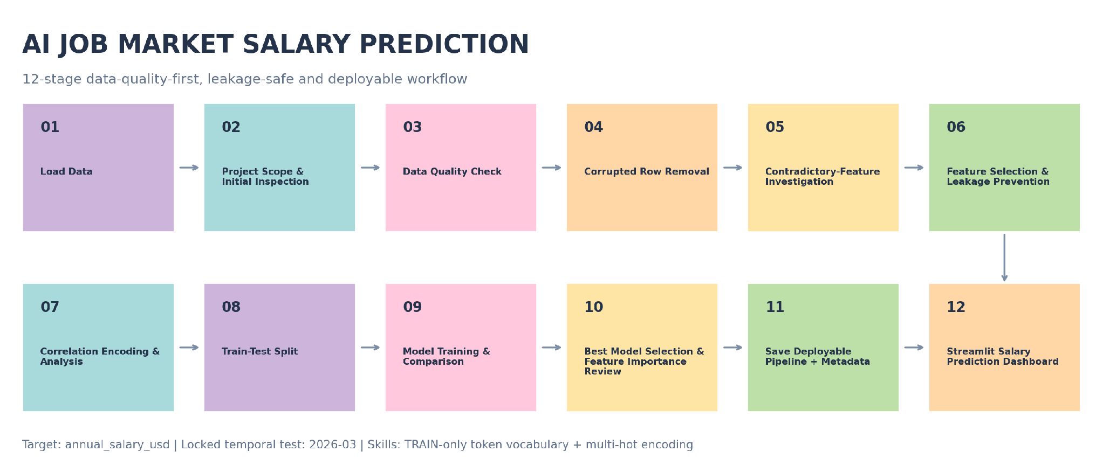
Leakage control Although Stage 8 is the formal split stage in the 12-stage academic presentation, the locked-period mask is declared before any target-aware diagnostics. All learned transforms and the 93-token skill vocabulary are fit on development/TRAIN data only.

STAGE 1. Load Data
1.1. To load raw AI Job Market Dataset:
Property | Observed value
File | ai_jobs_market_2025_2026.csv
Rows x columns | 1,500 x 25
File size | 378,914 bytes
Period | Jan 2025 to Mar 2026

1.2. Exploratory Data Analysis (EDA) and understand a real-world-style AI job market dataset:
Data Profiling:
# | Raw column | Canonical column | Logical type | Observed domain / range | Data rule | ML role
1 | job_id | job_id | String / ID | 1,500 unique; dạng AIJOB0001… | NOT NULL, UNIQUE, regex ^AIJOB\d{4}$ | BLOCK, unique posting identifier
2 | job_title | job_title | Nominal categorical | 25 categories | NOT NULL; unknown category được flag | KEEP
3 | AI Engineering | job_category | Nominal categorical | 13 raw values; 12 valid + 1 corrupted | "job_category" là invalid value → loại row / quarantine | KEEP after cleaning
4 | experience_level | experience_level | Ordinal categorical | Entry / Mid / Senior / Lead | NOT NULL; semantic audit với years | ABLATION
5 | years_of_experience | years_of_experience | Integer numeric | 1–15 | integer ≥ 0; semantic consistency check | ABLATION
6 | education_required | education_required | Ordinal categorical | 5 levels | explicit ordered categories | KEEP
7 | annual_salary_usd | annual_salary_usd | Integer numeric | 90,000–384,000 | > 0; NOT NULL | TARGET
8 | salary_min_usd | salary_min_usd | Integer numeric | 90,000–180,000 | > 0; min ≤ max | BLOCK — target adjacent
9 | salary_max_usd | salary_max_usd | Integer numeric | 180,000–320,000 | > 0; max ≥ min | BLOCK — target adjacent
10 | city | city | Nominal categorical | 20 cities | NOT NULL; unknown → OOD flag | KEEP / ABLATE
11 | country | country | Nominal categorical | 14 countries | NOT NULL; validate city-country pair | KEEP / ABLATE
12 | remote_work | remote_work | Nominal categorical | On-site, Hybrid, Fully Remote | closed categorical domain | KEEP
13 | company_size | company_size | Ordinal/nominal categorical | 5 categories | controlled vocabulary | KEEP
14 | industry | industry | Nominal categorical | 12 industries | controlled vocabulary | KEEP
15 | required_skills | required_skills | Multi-label text | 1,500 unique strings; | delimited | tokenize only after split; train-only vocabulary  thêm một cột đánh số lượng skill_count | PHASE 2
16 | ai_salary_premium_pct | ai_salary_premium_pct | Float numeric | 3.0–18.0 | provenance/availability check | CONDITIONAL
17 | demand_score | demand_score | Integer numeric | 68–98 | numeric range validation | KEEP / ABLATE
18 | demand_growth_yoy_pct | demand_growth_yoy_pct | Float numeric | 5.0–87.8 | provenance/availability check | CONDITIONAL
19 | benefits_score_10 | benefits_score_10 | Integer numeric | 6–10 | integer, recommended domain 0–10 | KEEP
20 | posting_year | posting_year | Integer / temporal | 2025–2026 | required for temporal split | SPLIT / CONDITIONAL X
21 | posting_month | posting_month | Integer / temporal | 1–12 | integer ∈ [1,12] | SPLIT / CONDITIONAL X
22 | is_senior | is_senior | Boolean / binary | 0,1 | exact derived flag | BLOCK
23 | is_remote_friendly | is_remote_friendly | Boolean / binary | 0,1 | exact derived flag | BLOCK
24 | is_llm_role | is_llm_role | Boolean / binary | 0,1 | exact derived flag by role family | BLOCK
25 | salary_tier | salary_tier | Ordinal categorical | 5 tiers | salary-derived semantic audit | BLOCK — target leakage

STAGE 2. Project Scope & Initial Inspection
- Scope: question & expectation: This project focuses on AI Job Market Data Cleaning, Exploratory Data Analysis, and Salary Prediction Modelling, demonstrating a careful, skeptical approach to validating a dataset before trusting it for machine learning - AI Job Market Salary Prediction.
- Understand dataset dimensions, dataset preview and shape inspection (df.head(), df.info()) and shape, dtypes
- descriptive statistical summaries (df.describe())
- profiling/ dictionary, describe
- data schema & rule
- Formal Task Definition
Component | Definition
Task type | Supervised regression (using unsupervised regression?)
Modeling unit | One job posting / one CSV row after data-quality gates
Target y | annual_salary_usd, integer USD/year
Input X | Only features known at prediction time and admitted by feature policy
Prediction moment | Before annual_salary_usd is known/finalized
Primary output | Predicted annual salary in USD
Recommended secondary output | Empirical prediction interval + OOD/review flag + top model drivers
Primary intended user | Analyst / student / decision-support user exploring salary benchmarks

- Target Distribution:
- annual_salary_usd ranges from $90,000 to $384,000;
- mean = $194,892;
- median = $180,000;
- standard deviation = $66,507.
- The IQR rule flags 8 high-end values above $373,500; these are not automatically removed because salary extremes can be legitimate. Outlier handling must be evidence-based and fit on TRAIN only.
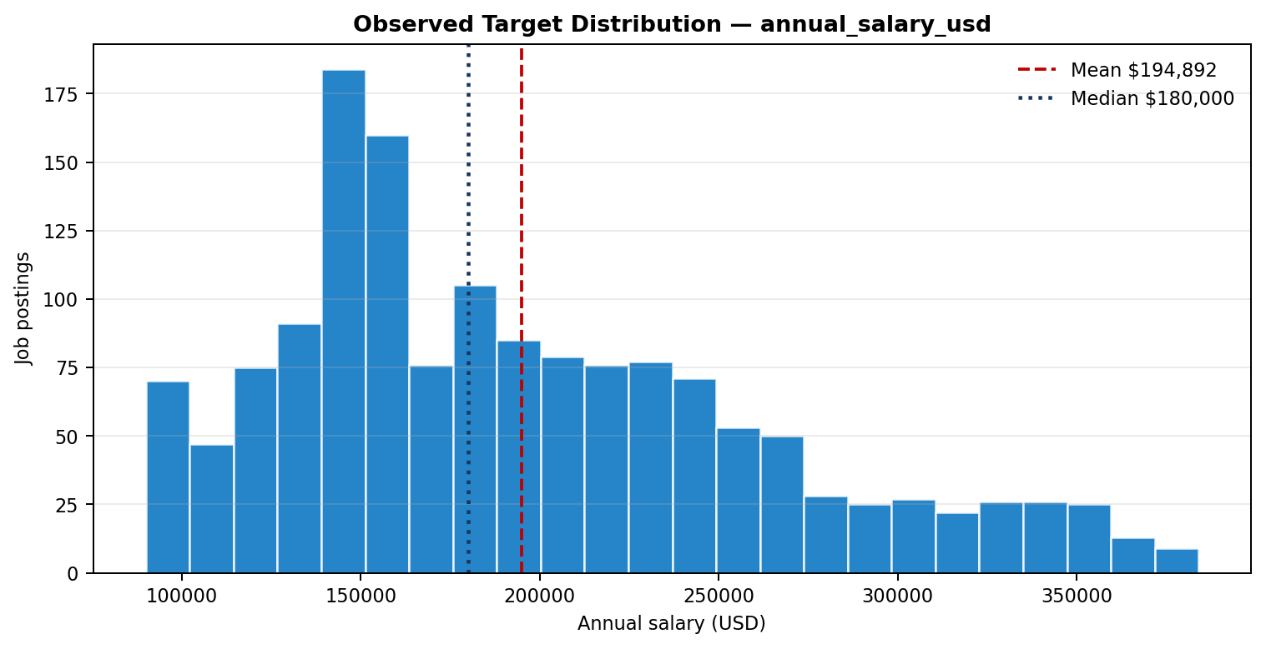
Figure 1. salary target distribution from the raw CSV.

STAGE 3. Data Quality Check
- detect nulls and duplicate records
- sanity-check every categorical column's actual values: A full value_by_value sanity check of every categorical column — not just null/duplicate counts — was run, since those two checks alone miss corrupted values sitting inside otherwise valid-looking columns

STAGE 4. Corrupted Row Removal
- The AI Engineering column contained a value of "job_category" (count = 1, job_id AIJOB1205) — the column header itself had leaked into the data as a row value. This is exactly the kind of corruption that .isnull() and .duplicated() cannot catch, and it would have silently distorted any encoding or correlation work downstream.
- Since this affected only 1 row out of 1,500, the row was dropped outright rather than guessed or imputed, reducing the dataset from 1,500 to 1,499 rows.
Issue | Observed evidence | Magnitude | Required action
Categorical corruption | AI Engineering contains literal value "job_category" for AIJOB1205. | 1 / 1,500 | Remove row; do not impute an invented domain.
- Zero duplicate rows were found.

STAGE 5. Contradictory-Feature Investigation (Điều tra đặc trưng mâu thuẫn)
- To investigate contradictory features tell a consistent story before trusting either of them.
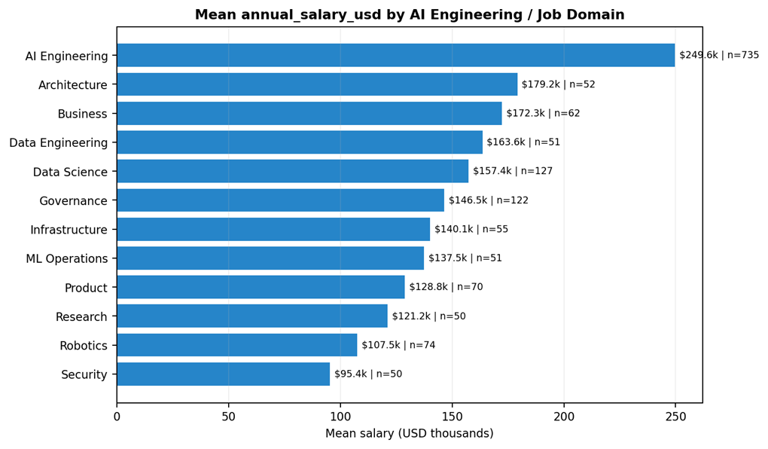
Figure 2a. mean salary by source job-domain field; the dominant domain-level separation is a synthetic-risk signal, not causal proof.

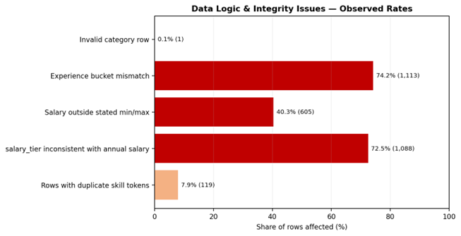
Figure 2b. share of rows affected by selected logic/integrity findings.

- Critical scientific interpretation. The dataset can support an academic exercise in supervised regression and ML systems design. It does not, by itself, support a claim that the learned relationships are faithful real-world salary economics. Strong feature importance must therefore be presented as dataset-fit behavior and tested with ablations - experience_level & years_of_experience vs target annual_salary_usd.

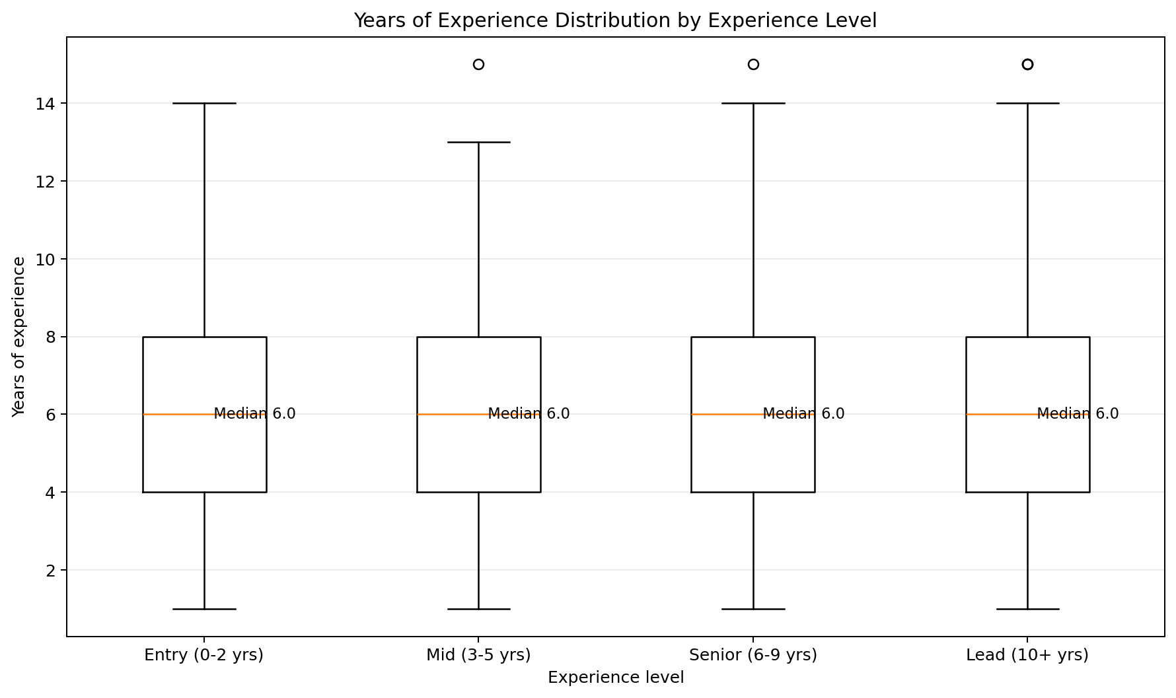
Figure 2c. year of experience distribution by experience level.
Mean Salary by experience_level (categorical bucket)
- Entry (0–2 yrs): ≈ $194,837
- Mid (3–5 yrs): ≈ $196,091
- Senior (6–9 yrs): ≈ $195,826
- Lead (10+ yrs): ≈ $193,037
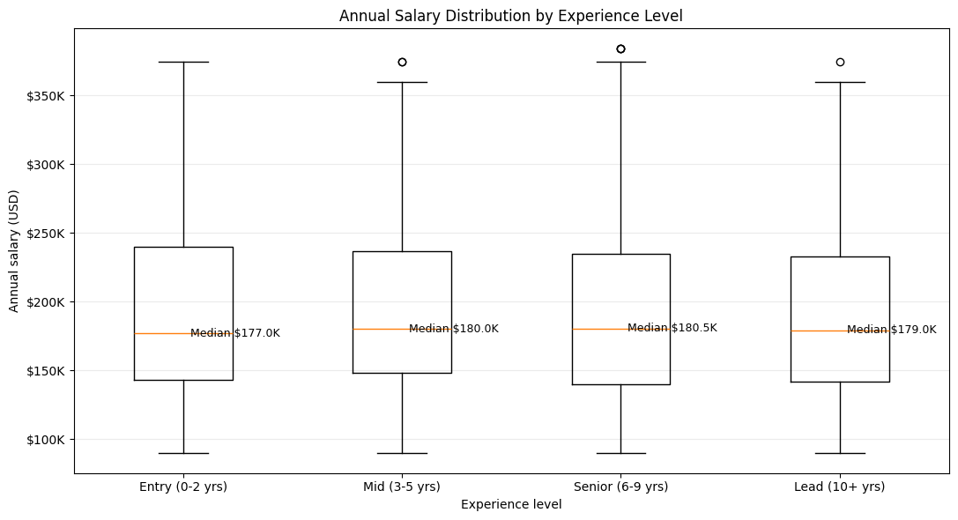
Figure 3. annual salary distribution by experience level.
Mean Salary by years_of_experience (raw numeric, selected values)
- 1 year: ≈ $325,800
- 5 years: ≈ $214,152
- 10 years: ≈ $132,020
- 15 years: ≈ $90,000
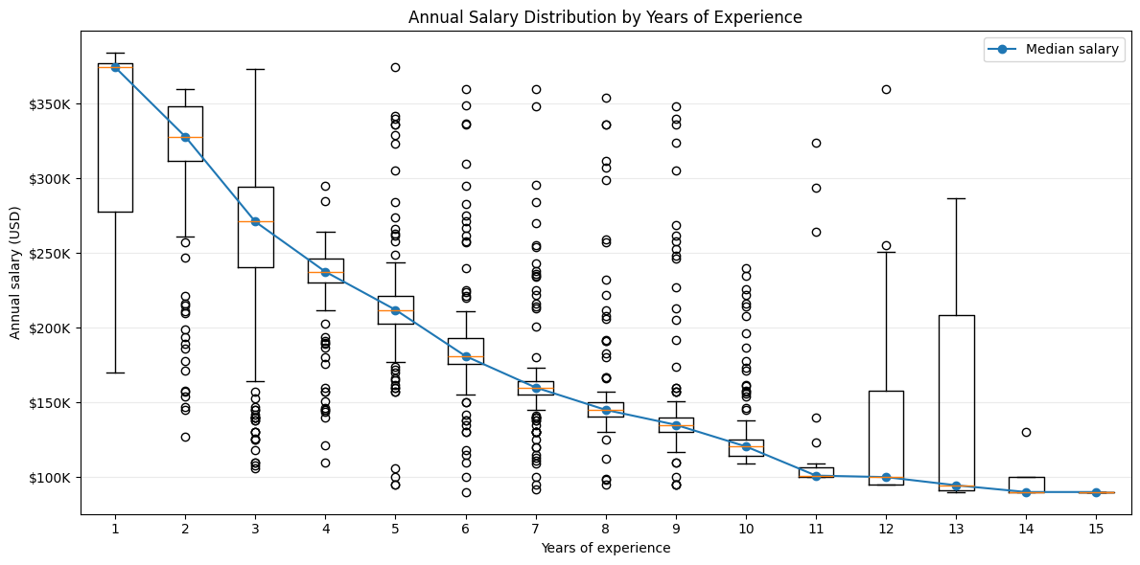
Figure 4a. annual salary distribution by years of experience.
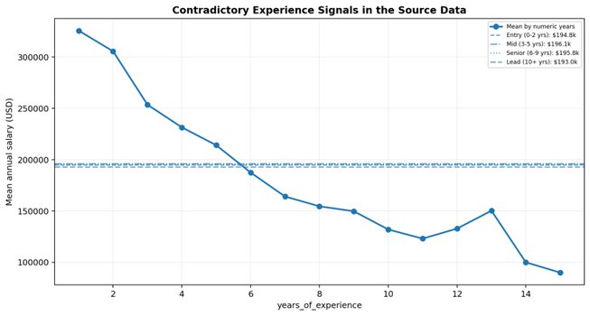
Figure 4b. years_of_experience shows a strong downward salary pattern while experience_level means are nearly flat.
Finding: experience_level shows salaries essentially flat across all four buckets (~$193k–$196k), while years_of_experience shows a strong downward trend. These two columns directly contradict each other and cannot both be reliable real-world signals.
Ablation study: Decision logic of Stage 5
years_of_experience
│
├─ Strong CV predictive value
├─ Strong OOT predictive value
├─ Granular numeric information
└─ KEEP WITH DOMAIN-VALIDATION FLAG
│
▼
annual_salary_usd
experience_level
│
├─ No standalone predictive value
├─ 74.2% logical inconsistency
├─ Redundant when logically consistent
├─ Apparent RF lift comes from contradiction
└─ DROP / QUARANTINE
Decision: this was treated as a data quality issue (most likely a synthetic-data generation artifact) rather than something to encode around silently. years_of_experience was kept as the more granular feature, experience_level was dropped as redundant and contradictory, and this relationship was flagged for cautious interpretation rather than trusted as a genuine pay-for-experience signal in any later write-up.
Issue | Observed evidence | Magnitude | Required action
Experience semantic mismatch | experience_level bucket disagrees with years_of_experience bucket. | 1,113 / 1,499 (74.2%) | Quarantine both as a contradictory feature family; run ablation and require provenance before semantic interpretation.

STAGE 6. Feature Selection & Leakage Preventaion
(drop leakage & unused columns)
6.1. Study feature correlation with the target variable:
A sorted bar chart of the top 25 features by absolute correlation with annual_salary_usd was plotted (a full heatmap becomes unreadable once job_title/city/etc. are one-hot encoded into 90+ columns).

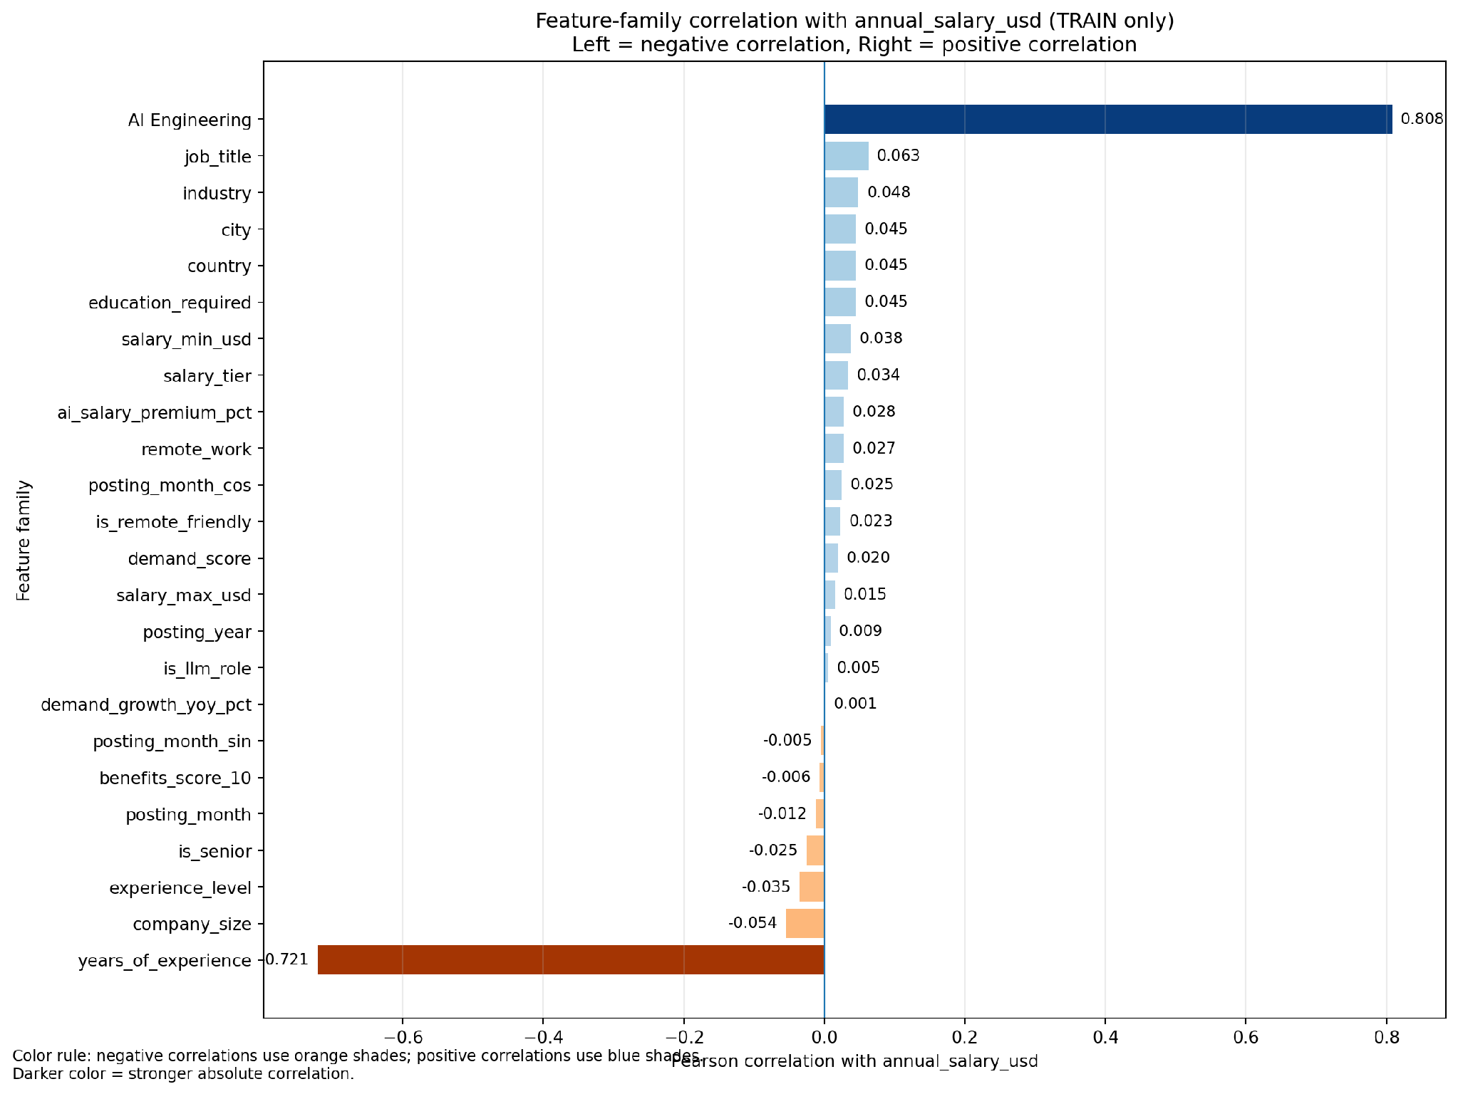
Figure 5. feature-family correlation on Train.

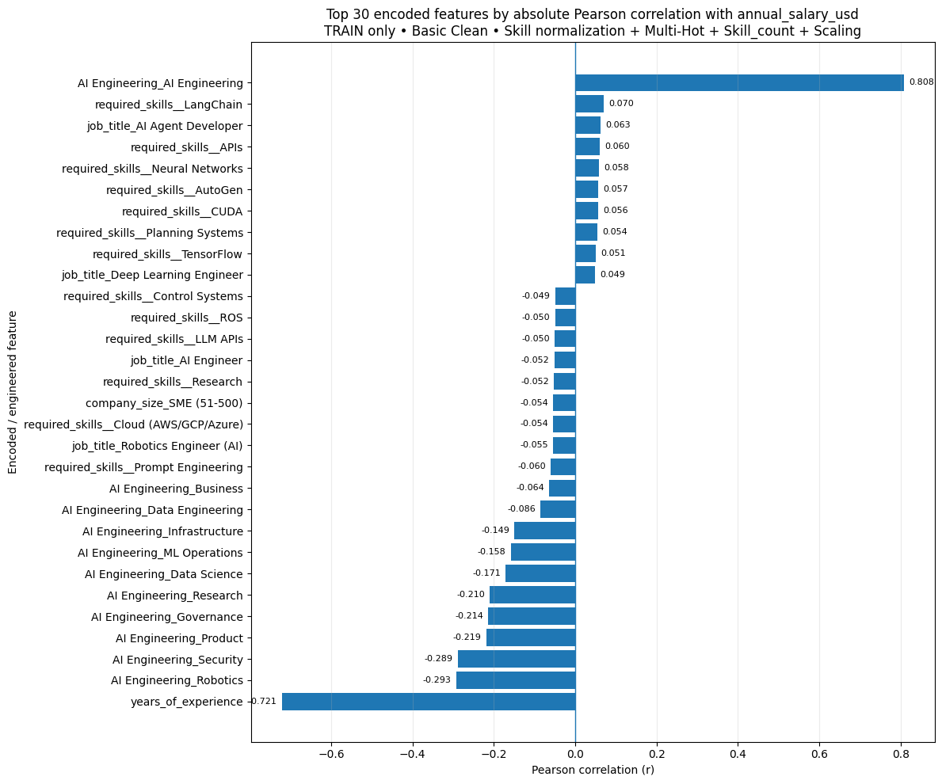
Figure 6. top 30 features by Pearson correlation on Train.

Figure 7. top 30 features by Pearson correlation on Train dataset.
Key Correlation Findings
- Strongest positive: job_category (old name = AI Engineering) ≈ +0.808 — belonging to this domain is associated with substantially higher pay.
- Strongest negative: years_of_experience ≈ −0.721 — consistent with the contradictory/synthetic-looking pattern flagged in stage 5.
- Other negative signals: AI Engineering_Robotics ≈ −0.293, AI Engineering_Security ≈ −0.289, AI Engineering_Product ≈ −0.219, AI Engineering_Governance ≈ −0.214
Because one-hot dummy columns are binary indicators, their correlation with salary is directly interpretable — it reflects whether belonging to that specific category is associated with higher or lower pay, unlike a single arbitrary LabelEncoder scale that would mix categories along one meaningless numeric axis.
6.2. Correlation analysis against the target variable: Columns that either leak the target or add no modelling value were removed:
- job_id — identifier, not a feature
Issue | Observed evidence | Magnitude | Required action
Feature functional dependency | job_title -> salary_min_usd, salary_max_usd and demand_score exactly (one value per title). | 25/25 titles | Avoid double-counting redundant features; use ablations.
- experience_level — redundant with, and contradicts, years_of_experience (see STAGE 5)
- salary_min_usd, salary_max_usd — leak the target (derived from the same salary structure)
- salary_tier — leaks the target (a binned version of it)
Issue | Observed evidence | Magnitude | Required action
Salary range inconsistency | annual_salary_usd is below salary_min_usd or above salary_max_usd. | 605 / 1,500 (40.3%) | Treat min/max as target-adjacent metadata, not trusted constraints.
Salary tier inconsistency | salary_tier does not match annual_salary_usd band by label definitions. | 1,088 / 1,500 (72.5%) | Block from primary X and do not use as target derivative.

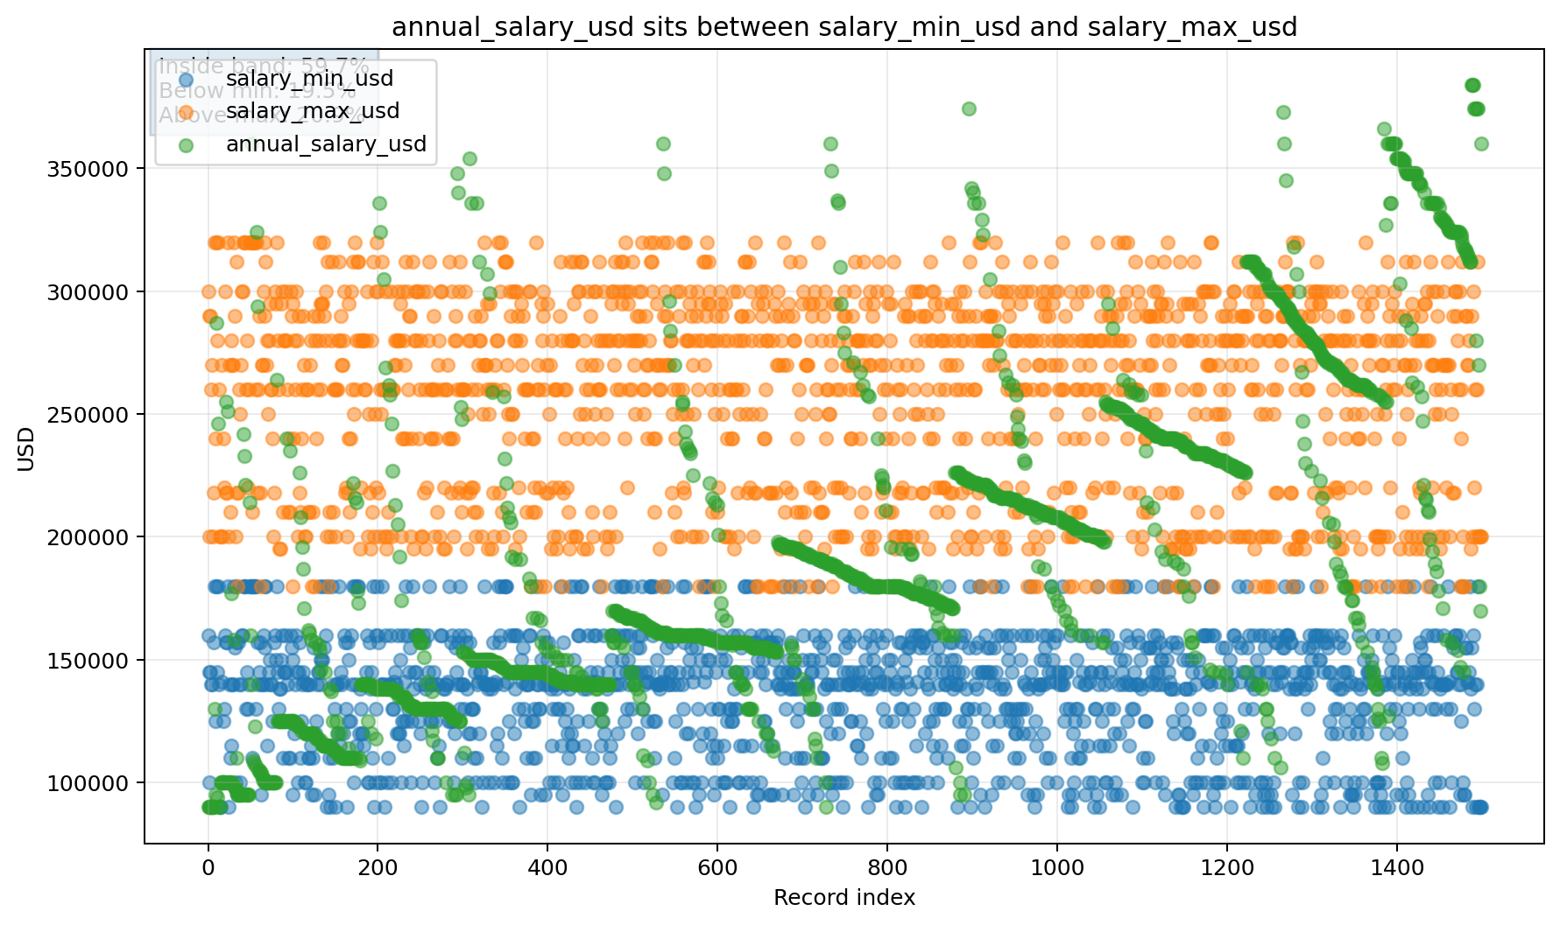
Figure 8a. salary range inconsistency.

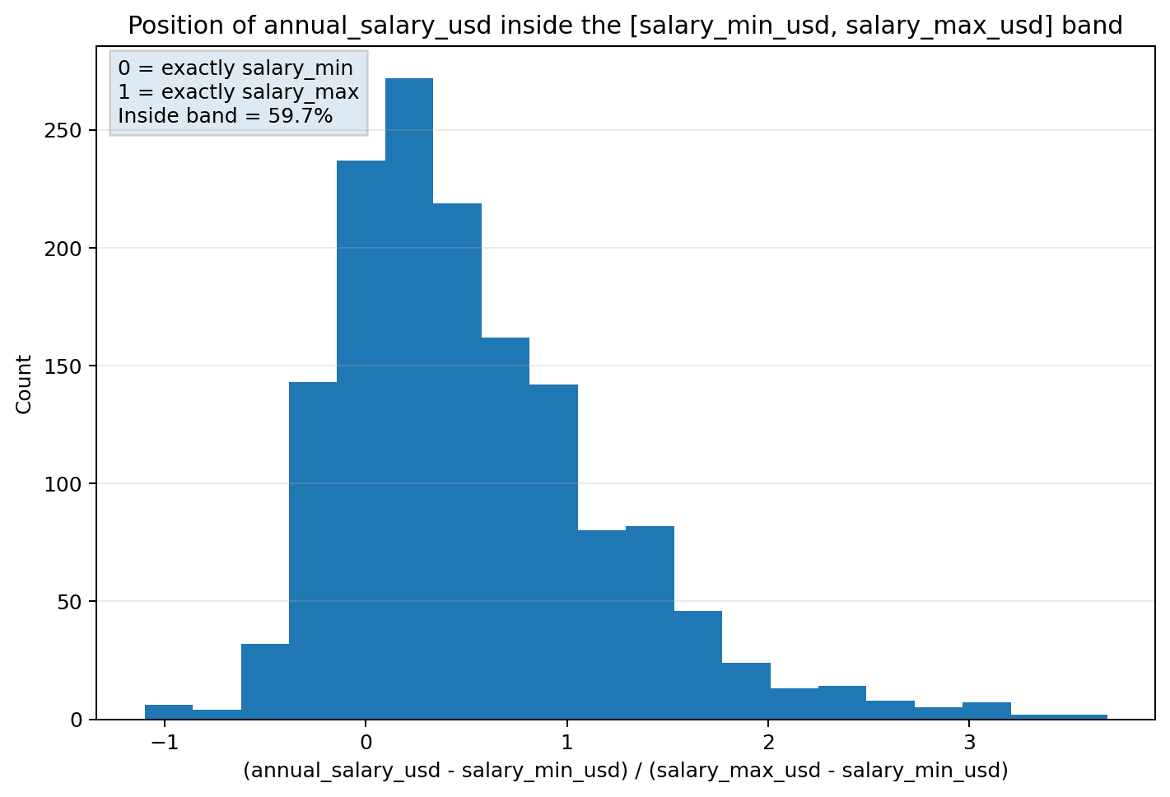
Figure 8b. salary range inconsistency ~40.3%.

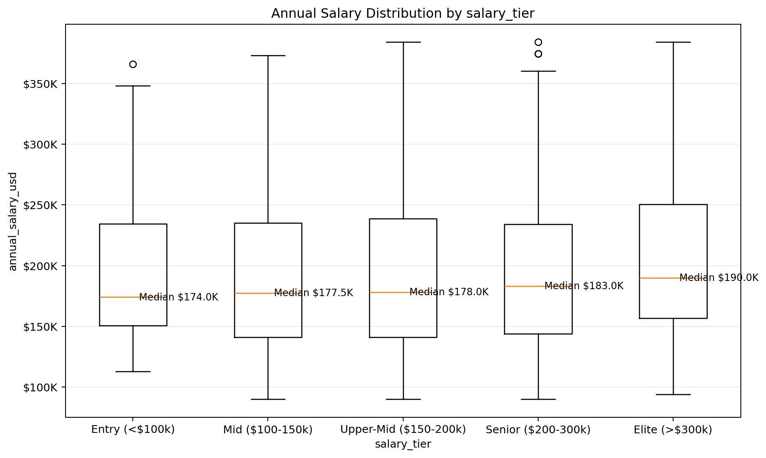
Figure 9. salary tier inconsistency.
- required_skills — free text, would need separate NLP treatment

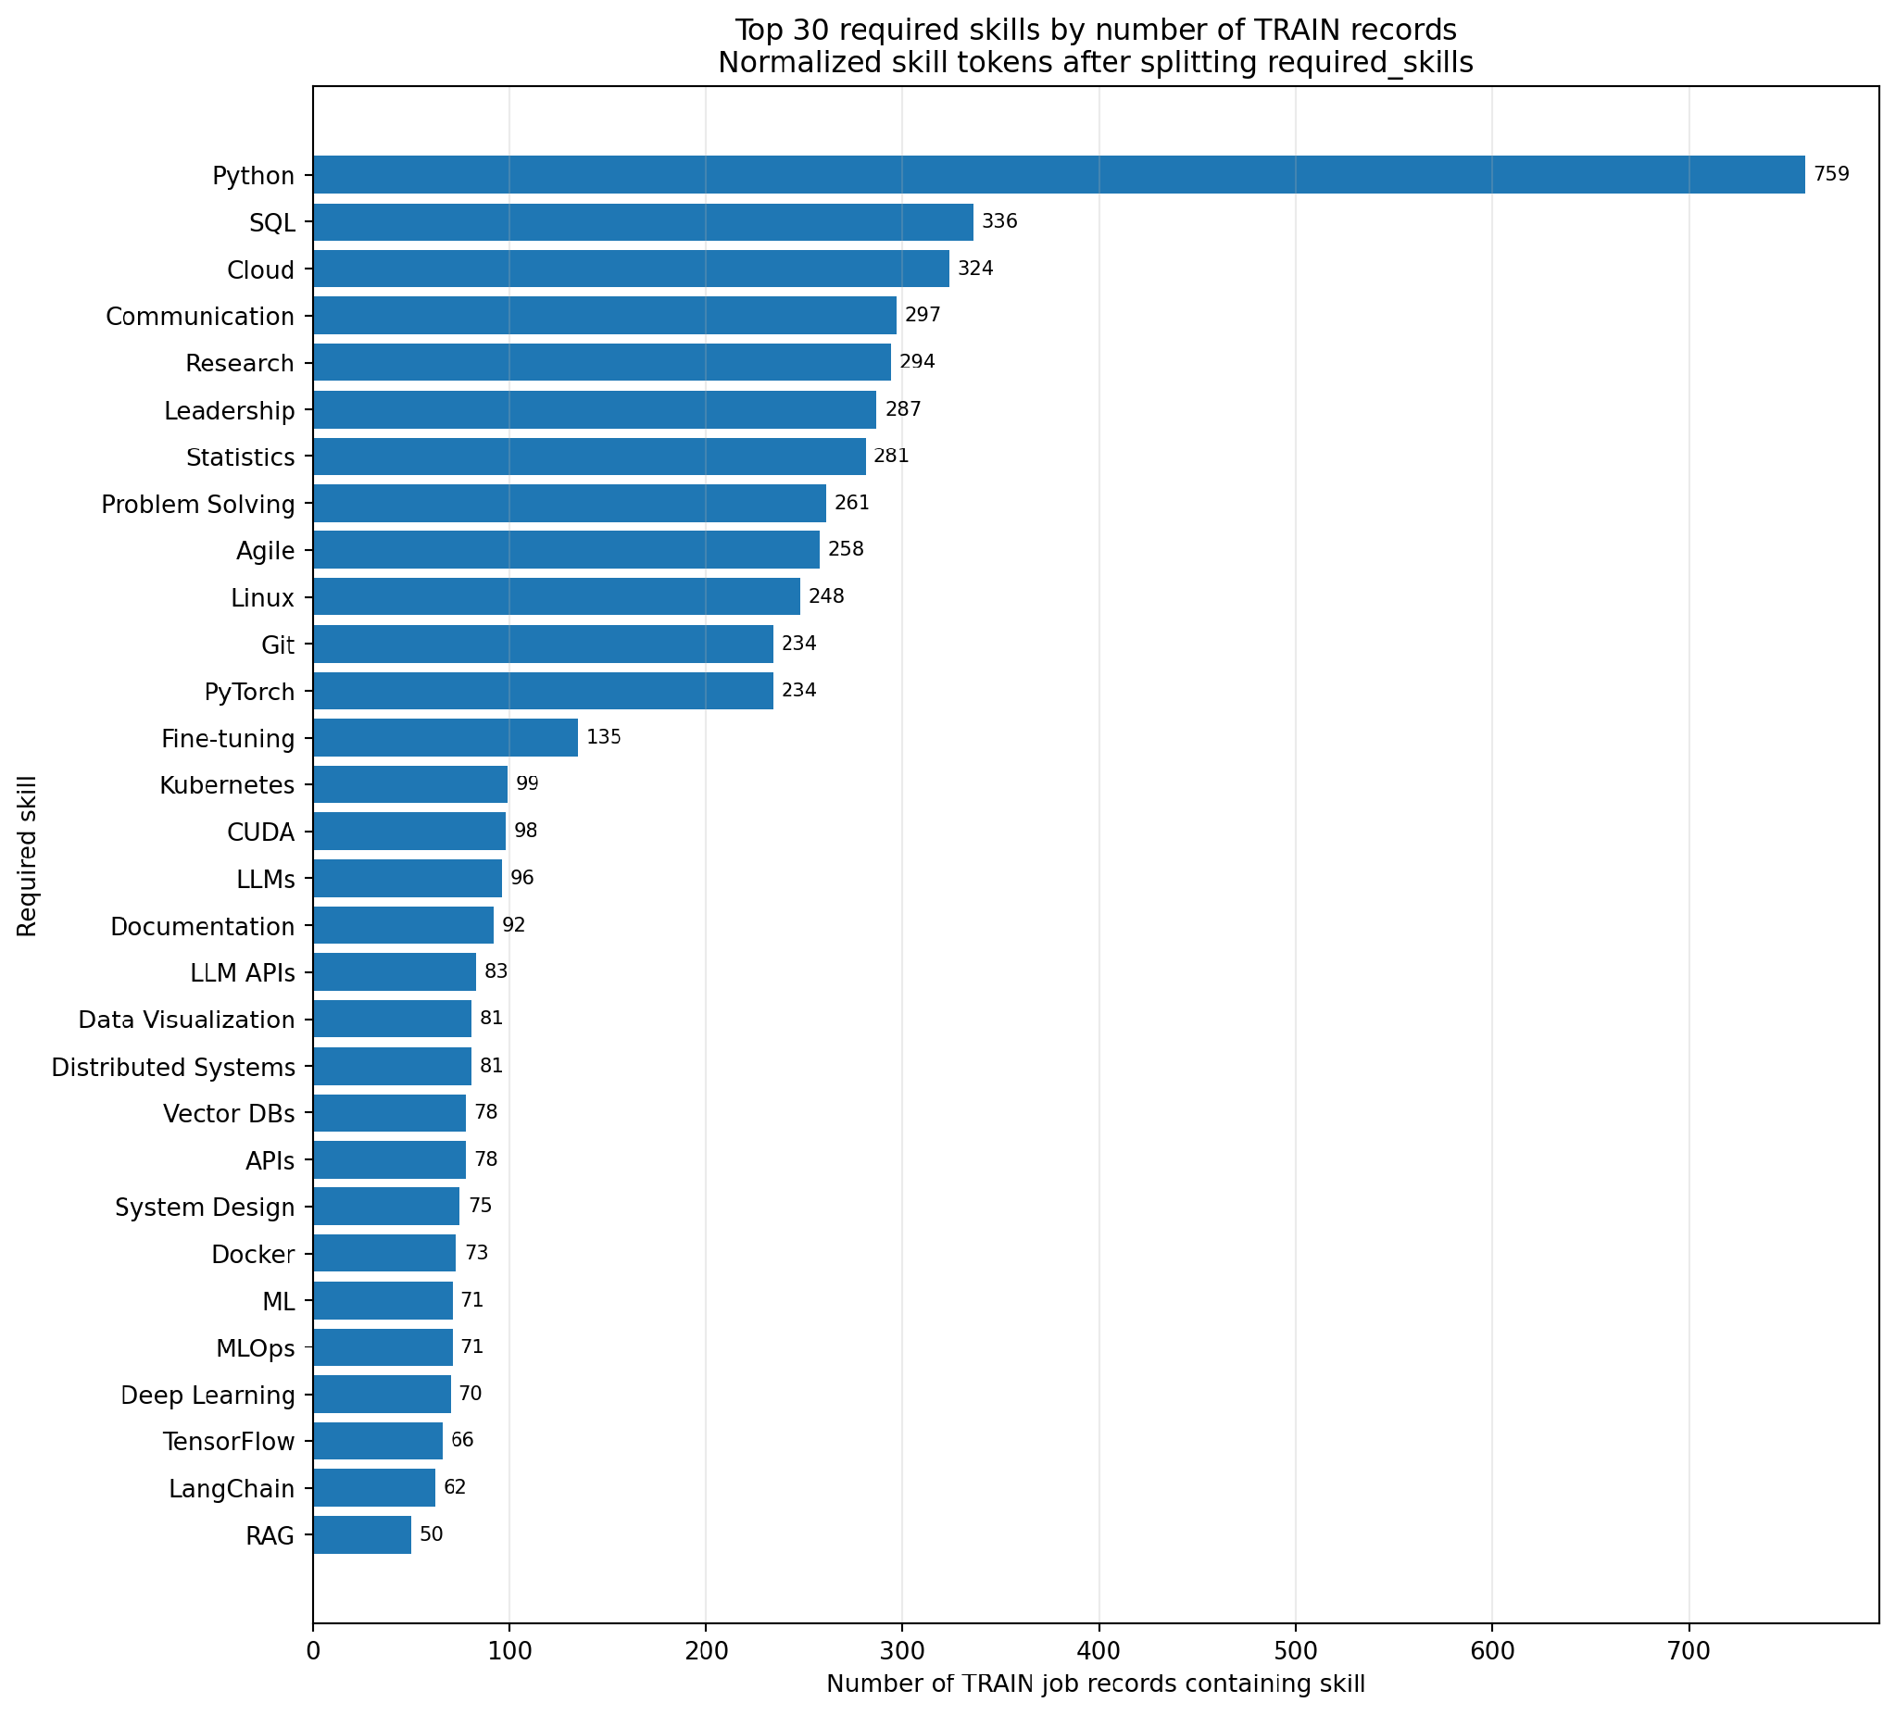
Figure 10. top 30 required skills on Train dataset.
- posting_year, posting_month, is_senior, is_remote_friendly, is_llm_role, ai_salary_premium_pct, demand_growth_yoy_pct — not used as modelling inputs
Redundant :
Issue | Observed evidence | Magnitude | Required action
Derived redundancy | is_senior exactly follows experience_level; is_remote_friendly exactly follows remote_work; is_llm_role is deterministic by job_title. | 0 mismatches for first two | Remove duplicate flags from the primary feature set.
Location redundancy | Each city maps to exactly one country in the current snapshot. | 20 cities -> 20 city-country pairs | Compare city-only, country-only and both; prefer stable generalization.

The final modelling feature set (11 columns): job_title, job_category (old name = AI Engineering), years_of_experience, education_required, city, country, remote_work, company_size, industry, demand_score, benefits_score_10 — with annual_salary_usd as the target.
# | Canonical column | Logical type | Observed domain / range | Data rule | ML role
0 | job_title | Nominal categorical | 25 categories | NOT NULL; unknown category được flag | KEEP
1 | job_category | Nominal categorical | 13 raw values; 12 valid + 1 corrupted | "job_category" là invalid value → loại row / quarantine | KEEP after cleaning
2 | years_of_experience | Integer numeric | 1–15 | integer ≥ 0; semantic consistency check | ABLATION
3 | education_required | Ordinal categorical | 5 levels | explicit ordered categories | KEEP
Target | annual_salary_usd | Integer numeric | 90,000–384,000 | > 0; NOT NULL | TARGET
4 | city | Nominal categorical | 20 cities | NOT NULL; unknown → OOD flag | KEEP / ABLATE
5 | country | Nominal categorical | 14 countries | NOT NULL; validate city-country pair | KEEP / ABLATE
6 | remote_work | Nominal categorical | On-site, Hybrid, Fully Remote | closed categorical domain | KEEP
7 | company_size | Ordinal/nominal categorical | 5 categories | controlled vocabulary | KEEP
8 | industry | Nominal categorical | 12 industries | controlled vocabulary | KEEP
P2 (*) | required_skills | Multi-label text | 1,500 unique strings; | delimited | tokenize (need separate NLP treatment) only after split; train-only vocabulary  thêm một cột đánh số lượng skill_count | PHASE 2
9 | demand_score | Integer numeric | 68–98 | numeric range validation | KEEP / ABLATE
10 | benefits_score_10 | Integer numeric | 6–10 | integer, recommended domain 0–10 | KEEP
Split | posting_year | Integer / temporal | 2025–2026 | required for temporal split | SPLIT / CONDITIONAL X
Split | posting_month | Integer / temporal | 1–12 | integer ∈ [1,12] | SPLIT / CONDITIONAL X

6.3. Target leakage investigation (Điều tra rò rỉ mục tiêu)
- Feature Availability and Leakage Policy: A predictor is eligible only if it is (a) semantically meaningful for the use case, (b) available at inference time, (c) not derived from the target or a post-target process, (d) not an identifier/proxy memorizer, and (e) stable enough to generalize across the temporal holdout. Correlation alone does not prove or disprove leakage; provenance and generation logic are required.
Policy | Features | Reason
BLOCK | job_id; salary_min_usd; salary_max_usd; salary_tier; is_senior; is_remote_friendly; is_llm_role | Identifiers, target-adjacent compensation fields, or deterministic redundant flags.
CONTRADICTORY ablation | years_of_experience; experience_level | Do not silently choose one as truth; compare feature families and document sensitivity.
CONDITIONAL | ai_salary_premium_pct; demand_growth_yoy_pct; posting_year; posting_month | Use only after availability/provenance and temporal-proxy checks.

- Required Feature-Family Ablation Experiments:
Experiment | Feature set | Decision question
A0 - Conservative | Core categorical + education + benefits; no experience; no target-adjacent fields. | Reference for plausibility.
A1 - + years | A0 + years_of_experience | Measure predictive gain from the suspicious numeric experience signal.
A2 - + experience bucket | A0 + experience_level, excluding numeric years | Compare the alternate experience representation.
A3 - Geography | Country-only vs city-only vs both | Check redundancy and unseen-location risk.
A4 - Demand | With vs without demand_score | Because demand_score is exactly determined by job_title.
A5 - Time | With vs without posting year/month | Detect temporal proxy dependence.
A6 - Skills (Phase 2) | Tokenized skills added to the selected structured feature set | Measure incremental signal without raw-string memorization.

STAGE 7. Correlation Encoding & Analysis
(PIC = Duy AI)
- All preprocessing lives inside a scikit-learn Pipeline/ColumnTransformer serialized with the model.
7.1. Imputation and Transformation:
- Imputation (Điền khuyết): Thực hiện tính toán (ví dụ: Median) trên tập Train và áp dụng giá trị đó lên tập Test. Với lương, nên dùng Median thay vì Mean vì lương thường có phân phối lệch (skewed).
- Log Transformation: Dữ liệu lương thường bị lệch phải (nhiều người lương thấp, ít người lương cực cao). Áp dụng log1p sẽ giúp phân phối chuẩn hơn, giúp các mô hình tuyến tính hoạt động hiệu quả hơn.
7.2. Correlation analysis & VIF - Variance Inflation Factor (Phân tích tương quan & Đa cộng tuyến) on Train:
- Correlation analysis (Phân tích tương quan): Sử dụng Pearson hoặc Spearman để xem các yếu tố như "Level", "Skill" tương quan thế nào với "Salary".
- VIF (Variance Inflation Factor): Kiểm tra hiện tượng đa cộng tuyến giữa các biến độc lập.
7.3. Encoding (Mã hóa):
- Nominal categoricals: OneHotEncoder job_title, AI Engineering, city, country, remote_work, company_size, industry — with handle_unknown="ignore" so unseen categories at prediction time don't crash the app; use min_frequency only if supported by validation and documented.
- Education: OrdinalEncoder with explicit order Bootcamp/Self-taught < Associate's < Bachelor's < Master's < PhD. Unknown values map to a dedicated fallback code.

- Numeric values (years_of_experience, demand_score, benefits_score_10): median imputation for inference robustness even though current training snapshot has no missing values; fit median on TRAIN only.
- Skills (Phase 2): split on |, trim, de-duplicate tokens, build vocabulary on TRAIN, optionally MultiLabelBinarizer / token TF-IDF. Raw required_skills string is prohibited as a single categorical value.
Issue | Observed evidence | Magnitude | Required action
Skills data quality | required_skills raw string is unique per row; 119 rows contain repeated tokens. | 1,500 strings; 93 distinct tokens | Never one-hot raw strings; split tokens, de-duplicate within row, fit vocabulary on TRAIN.

- Không one-hot trực tiếp chuỗi raw: Nếu bạn biến mỗi chuỗi kỹ năng thành một cột one-hot, sẽ có hàng nghìn cột duy nhất (vì mỗi chuỗi là khác nhau), dẫn đến dữ liệu nhiễu và không dùng được.
- Tách token (split tokens): Cần tách chuỗi kỹ năng thành các từ/tokens riêng lẻ (ví dụ: "Python, SQL, Machine Learning" → ["Python", "SQL", "Machine Learning"]).
- Loại trùng trong từng dòng (de-duplicate within row): Nếu một kỹ năng lặp lại nhiều lần trong cùng một dòng, chỉ giữ một lần.
- Xây vocabulary trên tập TRAIN (fit vocabulary on TRAIN): Tạo danh sách kỹ năng duy nhất từ tập train, sau đó encode dữ liệu theo danh sách này. Điều này đảm bảo mô hình chỉ học từ những kỹ năng đã thấy trong train, tránh mismatch khi gặp dữ liệu mới.
- Important caveat: pd.get_dummies is fine for a one-off analysis dataframe, but is not safe to reuse for the deployed model — the exact set of dummy columns it produces depends on which categories exist in the full dataset. A single new row from a form won't contain every category, so get_dummies would silently produce a mismatched column set. The actual modelling pipeline (Section 15) uses a proper ColumnTransformer instead, specifically to avoid this problem.
7.4. Scaling (Thay đổi quy mô):
- StandardScaler for Ridge/ElasticNet/SVR; not required for tree ensembles. Use model-specific pipelines rather than one universal preprocessing compromise.
7.5. Feature Selection:
chị gửi em phần chị chỉnh lại cho rõ ràng, em thay vào mục C, Stage 7.5 nhé:
7.5. Feature Selection:
- The project employs a strategic, two-phase approach to feature selection:
• Phase 1: Begin with Lasso (L1 Regularization) to quickly eliminate "garbage" variables due to its simplicity and computational efficiency.
• Phase 2: Subsequently, utilize Recursive Feature Elimination (RFE) paired with robust models like Random Forest and SVM to achieve higher accuracy and gain deeper insights into the interactions between specific skills.
This combined strategy is designed to combat the "Curse of Dimensionality"—a phenomenon occurring when the number of features is excessively high relative to the sample size (1,500 rows in this dataset), causing data sparsity and making the model prone to learning random noise instead of actual patterns.

- Lasso (L1 Regularization - Embedded Method)
• Mechanism: Lasso incorporates a penalty term proportional to the sum of the absolute values of the coefficients into the loss function. This mathematical property shrinks the coefficients of non-contributing or redundant variables to exactly zero, effectively performing automated feature selection during model training.
• Application Strategy: Use Lasso as an initial automated filtering step to prune "weak" features (those with an R2<0.01) among the dozens of AI skill columns.
• Primary Benefit: Significantly increases Interpretability by highlighting the most influential predictors.

- RFE (Recursive Feature Elimination - Wrapper Method)
• Mechanism: RFE works by training a base estimator (e.g., Random Forest), ranking features by their calculated importance, and iteratively removing the weakest features until the optimal subset remains.
• Primary Benefit: Provides Resource Optimization by reducing dimensionality, leading to faster training times, lower memory consumption, and simplified maintenance.
• Technical Advantage: Unlike Lasso, RFE is more effective at capturing feature interactions—such as the synergistic relationship between Job Title and Required Skills.
• Project Strategy: For this AI market dataset, RFE will be integrated with TimeSeriesSplit (Expanding Window) to ensure that the selected features remain stable and predictive over the project's temporal range (Jan 2025 – Mar 2026).

7.6. Feature Construction:
- Feature Construction (Xây dựng đặc trưng mới):
- Tạo biến "Salary-to-Experience Ratio" để hiểu giá trị của một năm kinh nghiệm trong các mảng AI khác nhau.
- Skill Grouping: Nhóm các kỹ năng AI (ví dụ: gom "PyTorch", "TensorFlow", "Keras" thành "Deep Learning Frameworks") để giảm số lượng biến và tăng tính tổng quát.
- Cross-Validation: Luôn sử dụng K-Fold Cross-Validation trên tập Train để đảm bảo mô hình ổn định trước khi đánh giá cuối cùng trên tập Test.
- Tập Test cuối cùng (Hold-out): Mar 2026 (chiếm 20% dữ liệu, dùng để đánh giá mô hình sau cùng sau khi đã chọn được hyperparameter tốt nhất).
- Các Fold để Cross-Validation trên tập Train (Jan 2025 – Jan 2026):
  - Fold 1: Train (Jan 2025 – May 2025); Validation (Jun 2025).
  - Fold 2: Train (Jan 2025 – Jun 2025); Validation (Jul 2025).
  - Fold 3: Train (Jan 2025 – Jul 2025); Validation (Aug 2025).
  - Fold 4: Train (Jan 2025 – Aug 2025); Validation (Sep 2025).
  - Fold 5: Train (Jan 2025 – Sep 2025); Validation (Oct 2025).
  - Tiếp tục cho đến Feb 2026.
- Hướng dẫn thực hiện kỹ thuật (Logic Code): Để triển khai 5 folds này một cách chuẩn xác, bạn cần tuân thủ các quy tắc sau từ nguồn tài liệu:
- Tham số n_splits: Thiết lập n_splits=5 trong hàm TimeSeriesSplit của thư viện Scikit-Learn.
- Không xáo trộn (No Shuffling): Luôn đảm bảo shuffle=False để giữ đúng trình tự thời gian.
- Tính toán thống kê: Mọi bước như chuẩn hóa (Scaling) hay điền khuyết (Imputation) phải được tính toán thông số (.fit) trên phần Train của từng fold và chỉ áp dụng (.transform) lên phần Validation tương ứng để tránh rò rỉ thông tin.
- Cách đánh giá kết quả từ 5 Folds: Sau khi chạy xong 5 folds, bạn cần thực hiện các bên dưới.
- Tính điểm trung bình (Mean Score): Lấy trung bình cộng kết quả của 5 fold để có cái nhìn tổng quát về hiệu suất mô hình.
- Kiểm tra độ lệch chuẩn (Std Dev):
  - Nếu độ lệch giữa các fold thấp: Mô hình ổn định.
  - Nếu độ lệch cao (High Variance): Mô hình đang nhạy cảm với dữ liệu và có nguy cơ quá khớp (overfitting).
- So sánh với Baseline: Kết quả trung bình này phải cao hơn mô hình Dummy (mô hình dự đoán ngẫu nhiên) để đảm bảo mô hình có giá trị sử dụng.
- Residual Analysis (Phân tích phần dư): Sau khi huấn luyện, hãy kiểm tra biểu đồ phần dư để xem mô hình có dự đoán sai lệch nhiều ở các mức lương quá cao hay quá thấp hay không.
7.7. Preprocessing Contract:
Configuration Contract
project:
name: ai_job_market_salary_prediction
seed: 42
data:
path: data/raw/ai_jobs_market_2025_2026.csv
target: annual_salary_usd
canonical_rename:
"AI Engineering": job_category
split:
strategy: temporal
locked_test:
year: 2026
month: 3
features:
blocked: [job_id, salary_min_usd, salary_max_usd, salary_tier,
is_senior, is_remote_friendly, is_llm_role]
contradictory: [years_of_experience, experience_level]
phase2: [required_skills]
metrics:
primary: MAE
secondary: [RMSE, R2, MedAE]
artifacts:
output_root: outputs
bundle_path: artifacts/model_bundle.joblib
Configuration rule: Thresholds, allowed features, split dates, model search spaces and narrative acceptance criteria must live in versioned config files, not scattered as hard-coded constants across notebooks and Streamlit.
Stage Failure Policy
Failure | Pipeline response
Required column missing / wrong dtype | Fail closed; no training or serving. Emit schema error with column-level detail.
Invalid categorical token | Quarantine/drop if confidently corrupted and very low-volume; otherwise stop for rule decision.
Blocked feature enters X | Raise runtime error; invalidate experiment.
Preprocessing fitted before split | Invalidate run and rebuild from raw data.
Locked test used during tuning | Invalidate final performance estimate; create a new governed holdout if possible.
Unknown category at inference | Encode safely; set unseen-category flag; monitor rate.
Out-of-range numeric input | Predict only if policy allows; attach out-of-distribution / review flag.
Bundle reload changes prediction | Deployment release fails; do not serve.

STAGE 8. Train-Test Split
(PIC = Minh)
- Data followed time series:
- The split was performed on the raw cleaned df (not the get_dummies df_corr), since the modelling pipeline does its own encoding internally via ColumnTransformer
- training / testing: select all records of [posting_year = 2026, posting_month = 3] for testing (about 20%), the historical data for train (around 80%).
- Train shape: approximately 1,199 rows × 11 columns
- Test shape: approximately 300 rows × 11 columns
- Locked-test rule. 2026-03 is not part of CV. Test labels are not inspected until the feature set, model class, hyperparameters, interval policy and narrative template are frozen.
- Each candidate model was wrapped in a single scikit-learn Pipeline containing a ColumnTransformer preprocessor, so the saved artifact is the entire pipeline — encoder and model together.
BEFORE VS AFTER DATA PROCESSING
Aspect | Before Processing | After Processing
Data Structure | Raw, 25 columns incl. IDs, leakage & free text | Clean, 11 modelling features, leakage-free
Corrupted Values | Header value leaked into a data row (hidden) | Identified & removed
Experience Signals | Two contradictory experience columns | Investigated; redundant column dropped
Encoding | Unsafe pd.get_dummies (analysis-only) | Deployable ColumnTransformer pipeline
Target Leakage | High risk (salary_min/max/tier present) | Fully eliminated
Model Readiness | Not Ready | Fully Ready — single deployable artifact

This comparison highlights how a data-quality-first approach — going beyond nulls and duplicates — was essential to turning this dataset into a trustworthy modelling input.

STAGE 9. Model Training & Comparison
(PIC = Minh)
Purpose of Stage 9: compare the approved regression candidates on identical expanding monthly validation folds, quantify accuracy and runtime trade-offs, and freeze the model family before the March 2026 locked test is opened.
9.1. Baseline and candidate model ladder:
# | Candidate | Role | Technical rationale
0 | Dummy Median | Non-ML floor | Predicts the training-fold median; every promoted model must materially outperform it.
1 | Linear Regression | Transparent linear baseline | Tests whether salary is explained by a simple additive relationship.
2 | Ridge Regression | Regularized linear baseline | Uses an L2 penalty to stabilize coefficients after one-hot expansion.
3 | Random Forest | Nonlinear bagging candidate | Captures nonlinear interactions in mixed tabular data and supports importance review.
4 | Gradient Boosting | Nonlinear boosting challenger | Sequentially corrects residuals and provides a strong stability comparison.

Every candidate is wrapped in one scikit-learn Pipeline(preprocessor → estimator). Encoding, imputation and the skill vocabulary are fitted only on the training window of each fold, which prevents validation information from leaking into preprocessing.
9.2. Temporal cross-validation design:
Fold | Training window | Validation month
1 | Jan 2025 – Sep 2025 | Oct 2025
2 | Jan 2025 – Oct 2025 | Nov 2025
3 | Jan 2025 – Nov 2025 | Dec 2025
4 | Jan 2025 – Dec 2025 | Jan 2026
5 | Jan 2025 – Jan 2026 | Feb 2026
• No shuffling is used: each validation month is later than its training window.
• All 298 records from March 2026 remain locked during candidate comparison and tuning.
• Preprocessing is fitted on the training portion and applied to the validation month using transform only.
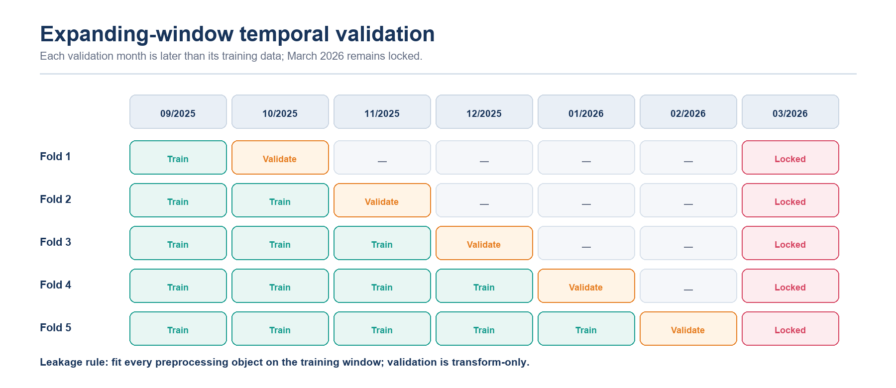
Figure 9. Expanding-window temporal validation. March 2026 remains locked until model selection and tuning are complete.
9.3. Evaluation metrics:
Metric | Priority | Interpretation
MAE | Primary | Average absolute salary error in USD; intuitive and less tail-sensitive than RMSE.
RMSE | Secondary | Penalizes large misses more strongly and exposes residual-tail risk.
R² | Diagnostic | Share of variance explained on the evaluated month; not evidence of causality.
MedAE | Robust diagnostic | Median absolute error, representing the typical prediction miss.

9.4. Temporal-CV model comparison:
Rank | Candidate | Mean MAE | MAE SD | Mean RMSE | Mean R² | Mean MedAE
1 | Random Forest | $12,594 | $2,887 | $22,923 | 0.878 | $5,216
2 | Gradient Boosting | $14,408 | $1,498 | $25,587 | 0.853 | $7,420
3 | Ridge Regression | $25,489 | $3,220 | $35,236 | 0.718 | $16,841
4 | Linear Regression | $28,827 | $3,380 | $38,680 | 0.658 | $20,606
5 | Dummy Median | $54,177 | $5,071 | $68,493 | −0.058 | $43,600

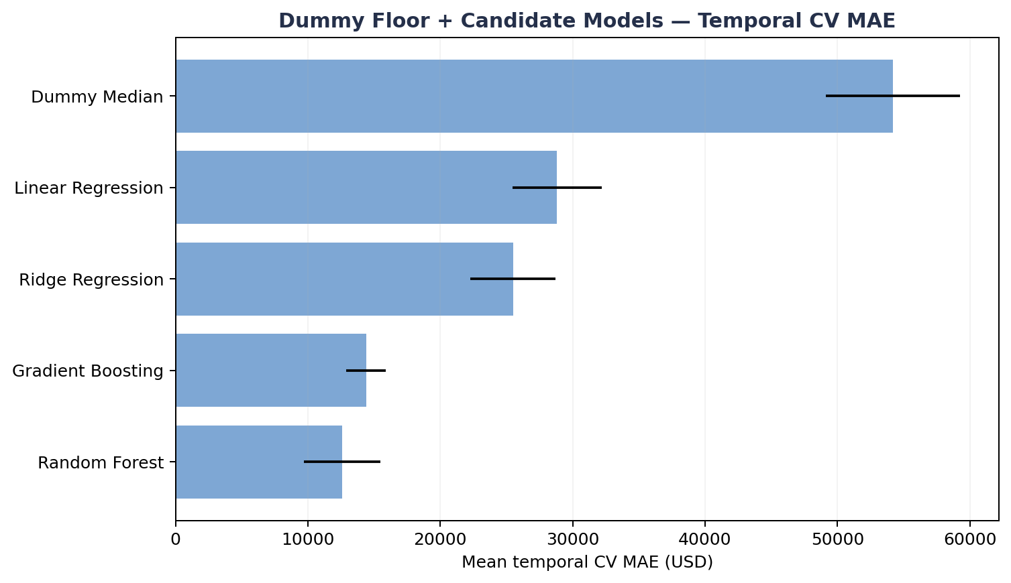
Figure 10. Mean temporal-CV MAE by candidate; lower values are better.
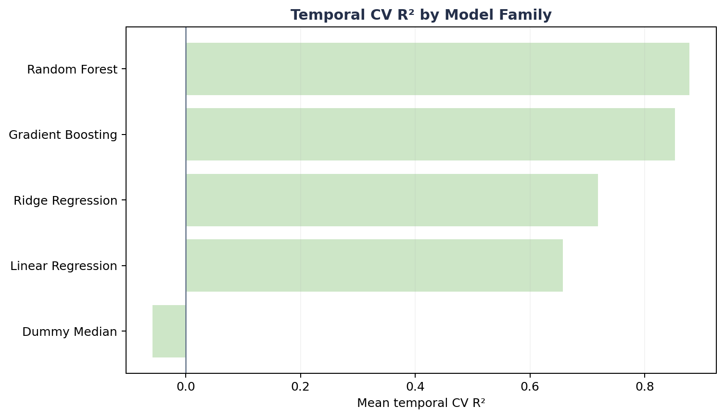
Figure 11. Mean temporal-CV R² by candidate; Random Forest provides the strongest out-of-time fit.
Result: Random Forest records the lowest mean MAE and the highest mean R². Its MAE is 12.6% lower than Gradient Boosting and 76.8% lower than the Dummy Median floor. Gradient Boosting varies less across months, but Random Forest provides the stronger aggregate accuracy evidence.
9.5. Runtime performance:
Candidate | Mean fit time / fold | Mean predict time / fold | Operational assessment
Dummy Median | 0.020 s | 0.010 s | Reference floor only
Linear Regression | 0.051 s | 0.010 s | Very fast
Ridge Regression | 0.023 s | 0.009 s | Very fast
Random Forest | 0.486 s | 0.016 s | Suitable for offline fitting and interactive inference
Gradient Boosting | 0.410 s | 0.010 s | Suitable for offline fitting and interactive inference

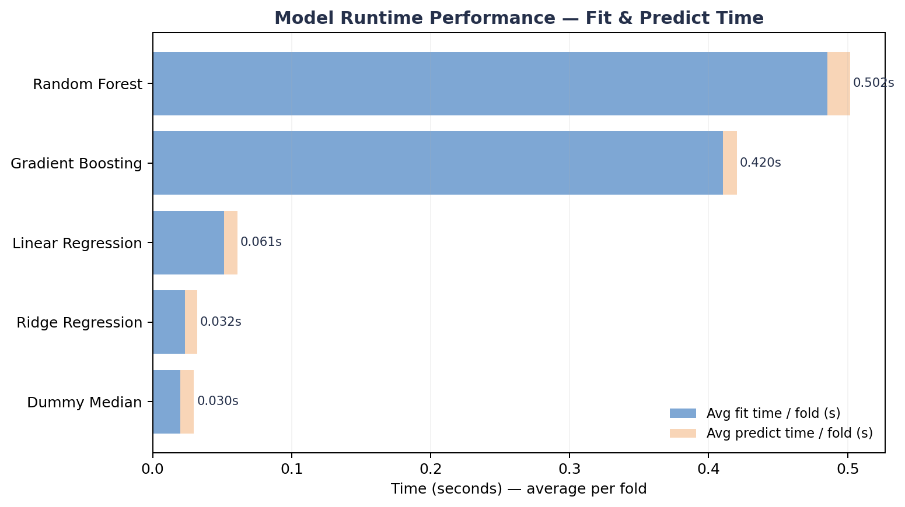
Figure 12. Mean fit and prediction time per temporal fold.
Assessment: both nonlinear candidates are operationally lightweight at this data scale. Model choice is therefore driven by temporal accuracy and diagnostic evidence rather than runtime.
9.6. Feature-family ablation:
Experiment | Feature set | Mean MAE | Improvement vs A0
A0 | Conservative core | $23,019 | —
A1 | A0 + years_of_experience | $12,357 | 46.3%
A2 | A0 + experience_level | $22,888 | 0.6%
A6 | A1 + required_skills + skill_count | $12,739 | 44.7%

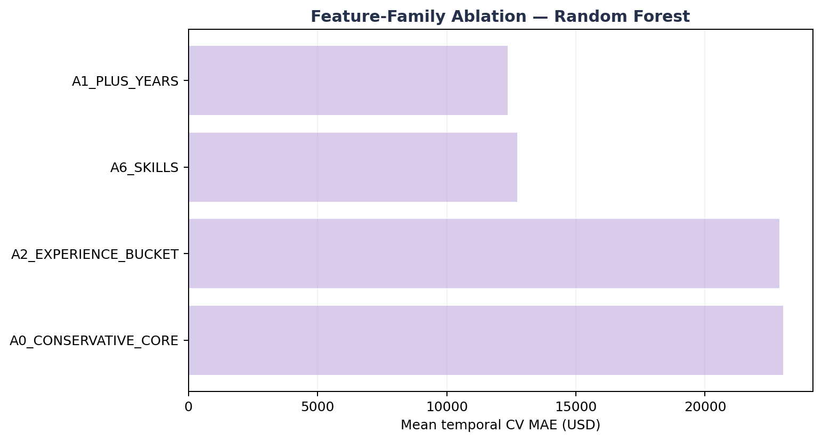
Figure 13. Feature-family ablation measured by mean temporal-CV MAE.
Assessment: years_of_experience provides the dominant predictive gain. The skill-aware A6 contract is 3.1% worse than A1 in this run, so skills should not be described as an accuracy improvement. They remain in the deployable contract for scenario detail and future retraining, with this limitation stated explicitly.
Stage outcome: Random Forest advances to bounded tuning in Stage 10. The family decision is frozen before the locked test is opened.

STAGE 10. Best Model Selection & Feature Importance Review
(PIC = Minh)
Purpose of Stage 10: tune the selected model family inside the development period, evaluate the frozen configuration once on the locked test, and distinguish predictive reliance from causal interpretation.
10.1. Bounded hyperparameter tuning:
Rank | Trees | Minimum leaf | Feature fraction | Maximum depth | CV MAE | MAE SD
1 | 300 | 2 | 0.7 | 20 | $12,425 | $3,115
2 | 100 | 2 | 0.8 | None | $12,497 | $3,018
3 | 80 | 1 | 0.8 | None | $12,581 | $2,998
4 | 200 | 1 | 0.7 | 20 | $12,615 | $3,012

Selected configuration: n_estimators=300, min_samples_leaf=2, max_features=0.7 and max_depth=20. This candidate achieves the lowest tuning CV MAE while constraining leaf size and tree depth on a modest development sample.
10.2. Final locked-test evaluation:
Selected model | Locked MAE | Locked RMSE | Locked R² | Locked MedAE | CV-to-test MAE gap
Random Forest | $15,005 | $29,819 | 0.803 | $4,354 | +20.8% vs tuning CV

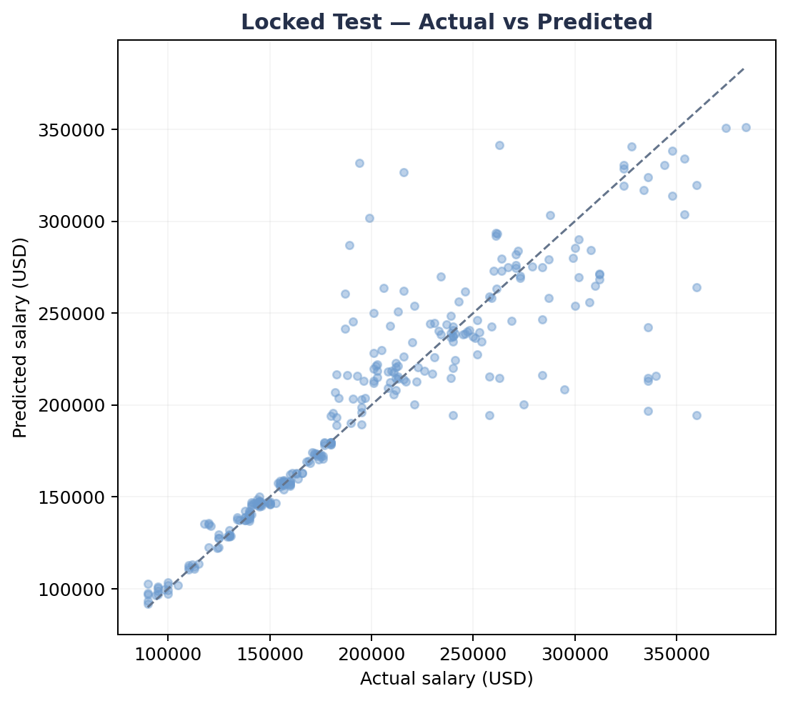
Figure 14. Actual versus predicted annual salary for the 298 locked-test records.
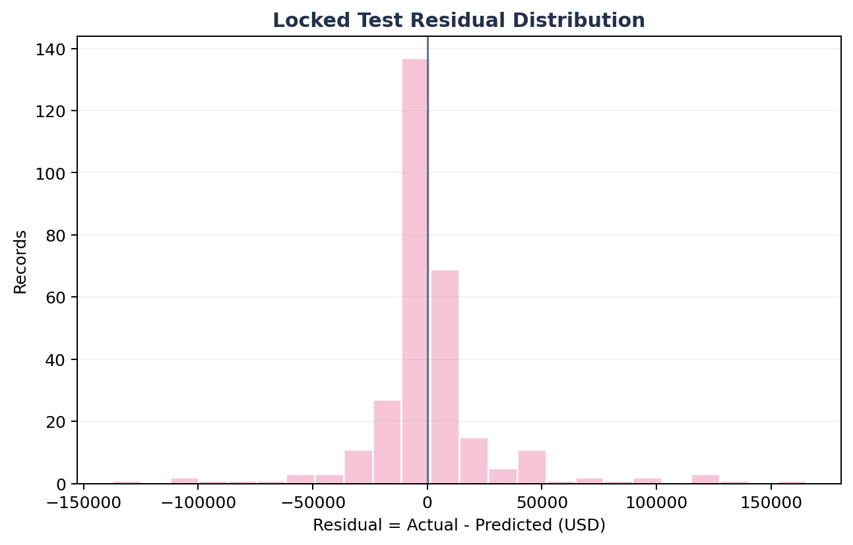
Figure 15. Locked-test residual distribution; the longer tail explains why RMSE is much larger than MedAE.
Evaluation: locked-test MAE is higher than the tuning-period CV MAE, which is expected for a strictly future month. The much lower MedAE relative to RMSE shows that most predictions are close, while a smaller number of large misses dominate tail-sensitive error.
10.3. Practical prediction interval:
Uncertainty item | Observed value | Interpretation
90th-percentile absolute error | $32,028 | Empirical width derived from held-out error
Displayed lower bound | max(0, prediction − $32,028) | Prevents a negative salary bound
Displayed upper bound | prediction + $32,028 | Symmetric practical error band

The interface must label this as an empirical validation-error band. It is not a formal confidence interval and does not guarantee 90% coverage on a new market.
10.4. Feature reliance review:
Method | Leading feature | Observed importance | Meaning
Encoded impurity | job_category_AI Engineering | 57.04% | Frequently used by the fitted trees to reduce training impurity
Encoded impurity | years_of_experience | 28.69% | Strong nonlinear split variable
Raw permutation | job_category | +$51,387 MAE | Largest loss when the raw field is destroyed
Raw permutation | years_of_experience | +$12,668 MAE | Second strongest model reliance

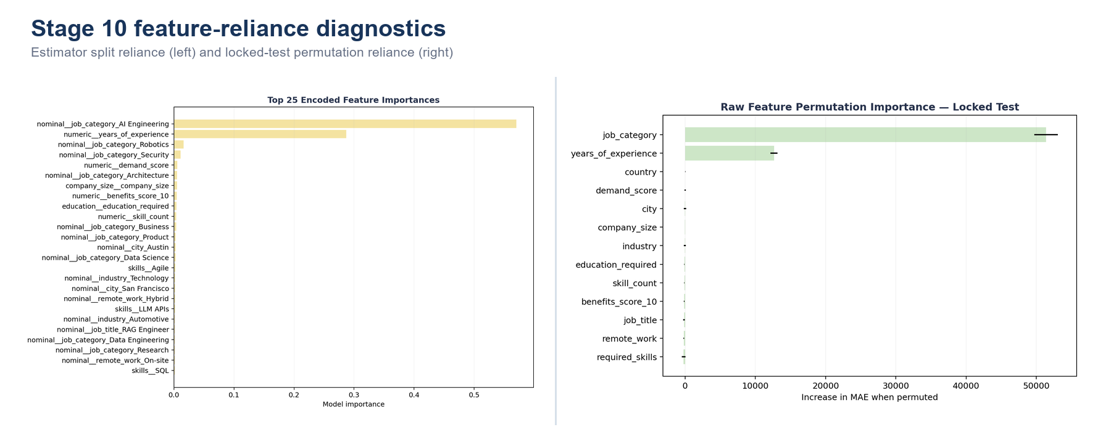
Figure 16. Encoded impurity importance and raw-feature permutation importance describe complementary forms of model reliance.
Interpretation: high feature importance does not mean low error for that category. AI Engineering is both the dominant split signal and the most heterogeneous locked-test segment (156 records; MAE approximately $26,319), so the model relies on it heavily while still making larger within-category errors. Importance measures model dependence, not class balance, accuracy or causality.
• The fitted model behaves largely as a two-signal system: job category plus years of experience.
• The experience relationship is synthetic-looking and contradictory in this dataset; reliance on it is not a real-world salary law.
• R²=0.803 describes fit to this locked month only and must not be extrapolated to the entire AI labor market.
Stage outcome: retain Random Forest for academic benchmarking and scenario exploration. External validation is required before operational compensation decisions.

STAGE 11. Save Deployable Pipeline + Metadata
(PIC = Hiển)
Purpose of Stage 11: package the fitted preprocessing and final estimator as one deployable pipeline, then store the metadata required to validate raw inputs and reproduce the offline inference contract.
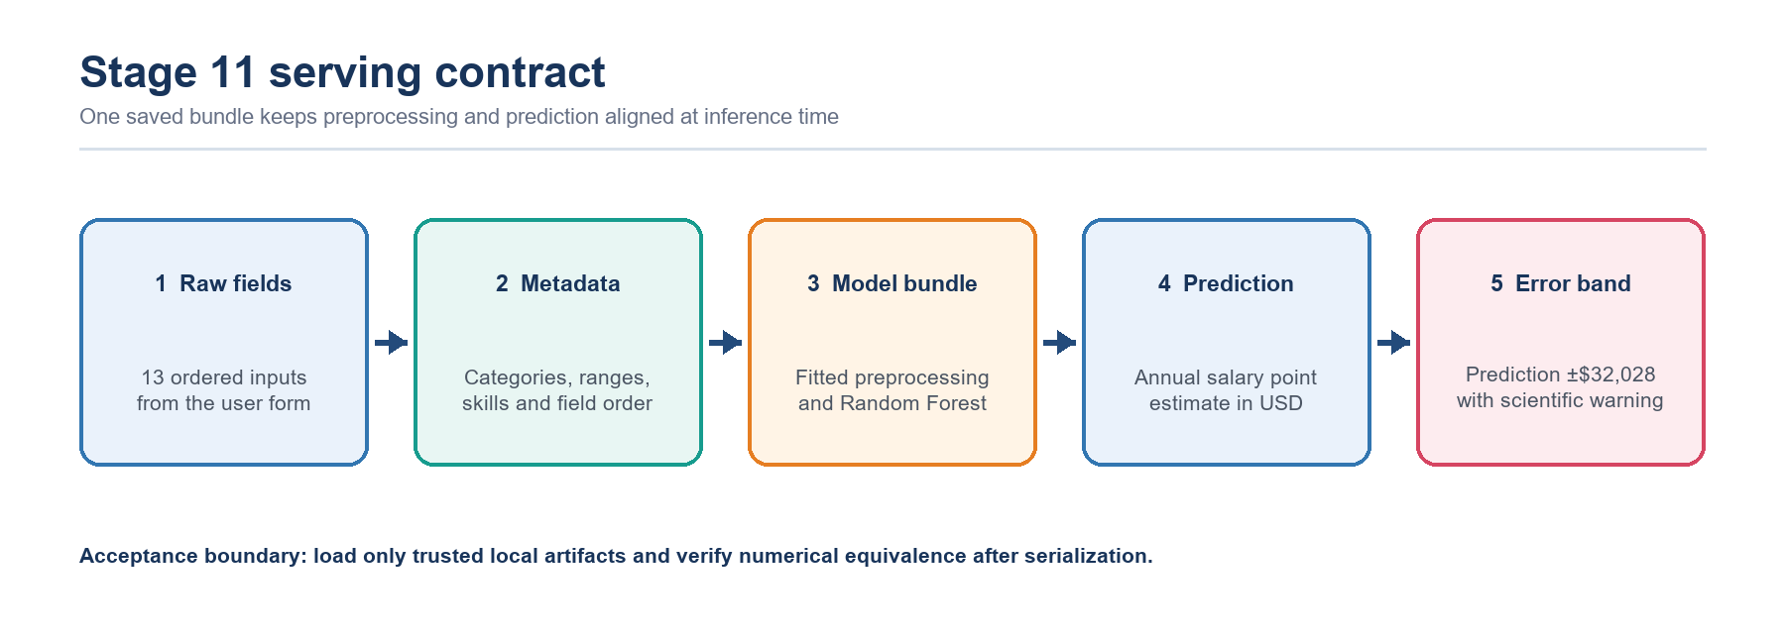
Figure 17. Serving flow from raw form fields through metadata validation and the saved model bundle to the point estimate and practical error band.
11.1. Serialized artifact contract:
Artifact | Purpose | Acceptance evidence
artifacts/model_bundle.joblib | Complete preprocessor + fitted Random Forest pipeline used by Streamlit | Loads without error
artifacts/preprocessor_ml_ready.joblib | Reusable fitted data transformer | File present and loadable
artifacts/metadata.json | Model identity, input contract, ranges, categories, skills, metrics and limits | Required keys validated
artifacts/feature_columns.json | Exact ordered raw feature contract | 13 fields in serving order
artifacts/11_bundle_equivalence.json | Reloaded-bundle numerical equivalence check | max_abs_diff = 0

11.2. Metadata data contract:
Metadata field | Current value | Streamlit use
model_name | Random Forest | Labels the inference result
model_features | 13 ordered raw inputs | Builds the serving DataFrame in the trained order
numeric_ranges | experience 1–15; demand 68–98; benefits 6–10 | Constrains numeric controls
category_options | Training-domain values | Populates select boxes
skill_vocabulary | 93 tokens | Populates the multiselect and derives skill_count
prediction_interval_abs_error_q90 | $32,028 | Calculates the displayed practical bounds
limitations | Four documented limitations | Shows the scientific-use boundary

{
"model_name": "Random Forest",
"model_features": ["job_title", "job_category", "years_of_experience", "..."],
"locked_test": {"year": 2026, "month": 3, "rows": 298},
"prediction_interval_abs_error_q90": 32027.76,
"selected_hyperparameters": {"n_estimators": 300, "min_samples_leaf": 2,
"max_features": 0.7, "max_depth": 20}
}

11.3. Packaging and verification procedure:
1. Fit the complete preprocessing and selected estimator on all 1,201 development records after model selection is frozen.
2. Serialize the entire pipeline as model_bundle.joblib so raw application fields follow the same transformation sequence used offline.
3. Write the ordered feature contract, categories, numeric ranges, skill vocabulary, final metrics, interval width and limitations to metadata.
4. Reload the bundle and compare predictions with the pre-save output under a strict numerical tolerance.
Check | Method | Acceptance criterion | Current status
Bundle load | joblib.load from the trusted local path | No exception | Passed
Feature order | Compare DataFrame columns with metadata | Exact 13-field order | Passed
Unknown categories | Run a controlled unseen-category record | No encoder failure | Supported by handle_unknown
Reload equivalence | Compare pre-save and reloaded predictions | max_abs_diff ≤ 1e−9 | Passed: 0
Provenance | Record package versions and timestamp | Reproducible environment | Keep with release evidence

Assessment: saving one end-to-end bundle minimizes training-serving skew. Metadata closes the loop between training and the UI, but production deployment still requires secret management, version provenance and external-data monitoring.

STAGE 12. Streamlit Salary Prediction Dashboard
(PIC = Hiển)
Purpose of Stage 12: provide an authenticated, metadata-driven Streamlit page that validates proposed job records, stores valid records in a session queue, predicts the full queue with the saved model bundle and communicates uncertainty for every result.
Latest interface clarification: the queue mechanism remains part of the Salary Prediction page. The only presentation change is the removal of the dedicated Stage 11 Deployment Gate panel from the Best Model page. This does not remove validation, metadata checks or the saved artifacts used during prediction; it removes a duplicated Stage 11 display from the Stage 10 evaluation page.
12.1. Authentication and role-based controls:
Role | Demo credential | Visible controls | Security note
Admin | admin / AIJob2026! | All evidence pages; manual demand and benefits fields | Local academic demonstration only
User | user / user123 | Simplified prediction view; market scores use training medians | Replace password handling before shared deployment

The selected role is stored in the Streamlit session. Admin users can edit the two market-score inputs; standard users do not see these fields and the application supplies the training-domain median values so the 13-field model contract remains complete. Environment variables may override the administrator account in a controlled deployment.
12.2. Separation of page responsibilities after the interface update:
Area | What is displayed | What remains active
Best Model page | Stage 10 tuning, locked-test metrics, diagnostics, importance and evaluation examples | No dedicated Stage 11 Deployment Gate panel is shown
Stage 11 artifact layer | Not presented as a separate tab inside Best Model | model_bundle.joblib, metadata.json and the ordered feature contract are still required by inference
Salary Prediction page | Stage 12 form, Validation Queue, batch results and CSV controls | Input validation, queue state and saved-bundle prediction remain unchanged

Design rationale: evaluation evidence and inference controls serve different purposes. Keeping Stage 10 evidence on Best Model avoids a duplicated deployment panel, while keeping the operational gate and queue on Salary Prediction preserves the complete user workflow.
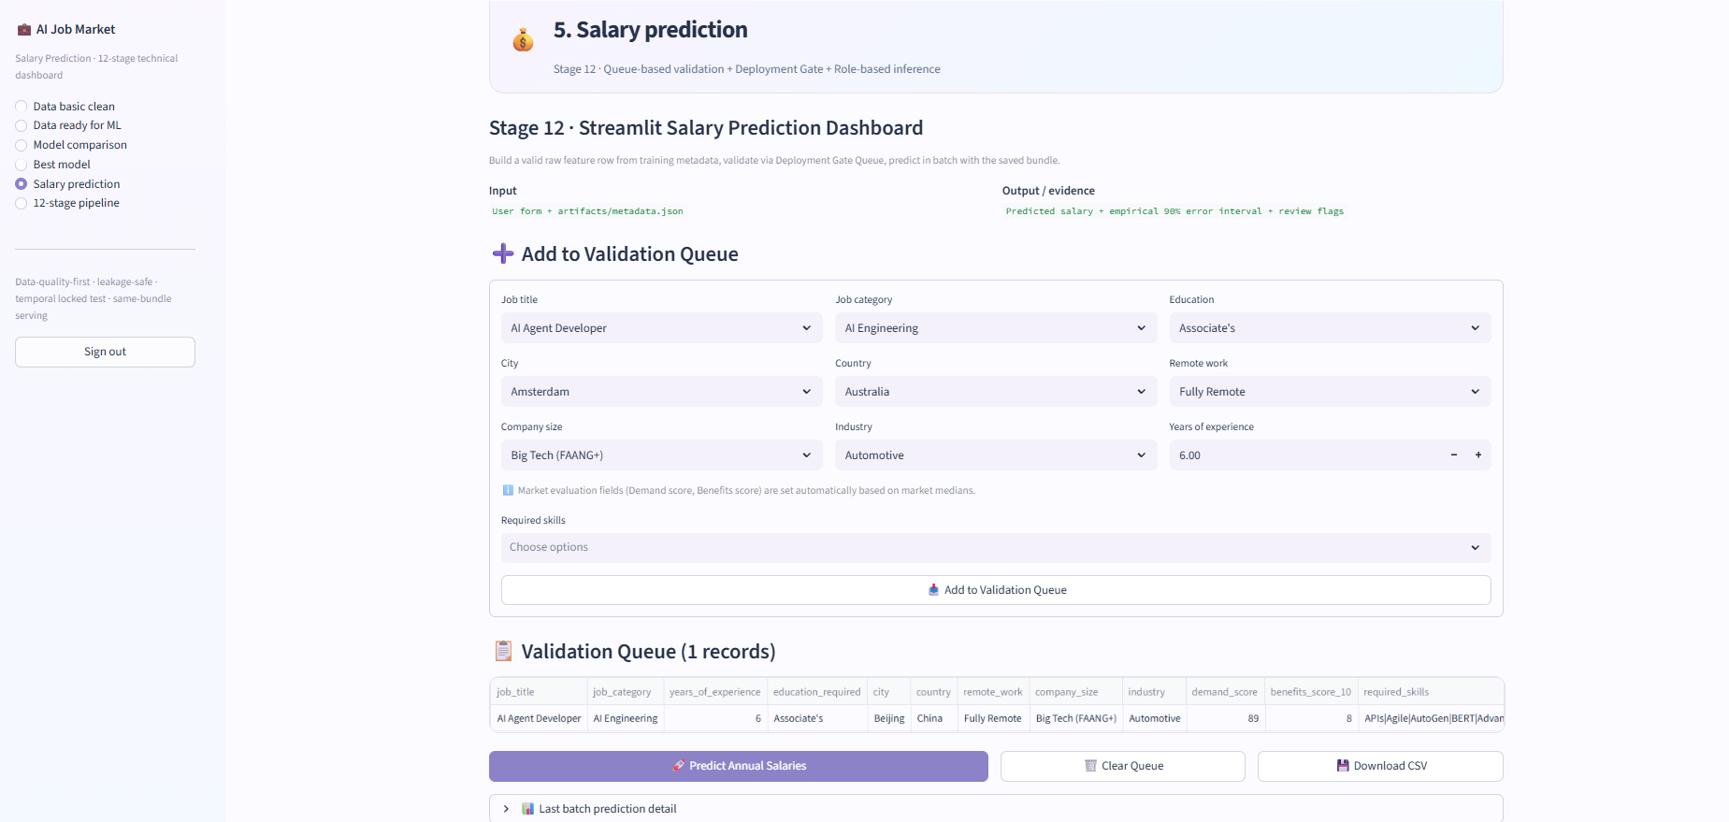
Figure 18. Current Salary Prediction page with Add to Validation Queue, queued records, batch prediction, queue clearing and CSV download controls.
12.3. Queue-based validation and batch prediction:
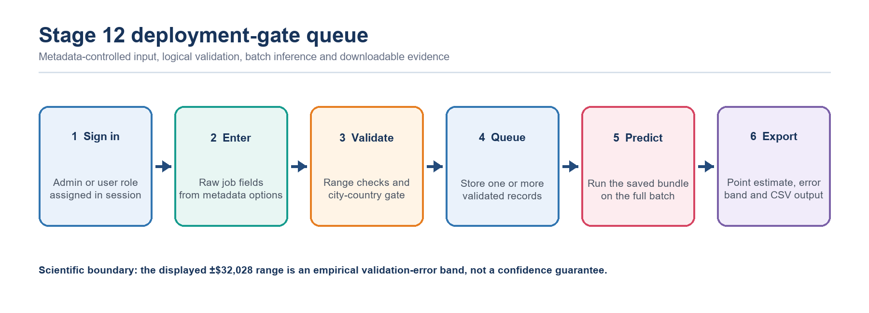
Figure 19. Stage 12 runtime flow: role-aware entry, logical validation, queue construction, batch inference and CSV export.
Input group | Fields | UI control | Validation source
Role | job_title, job_category | Select boxes | metadata.category_options
Experience | years_of_experience, education_required | Number input and select | Metadata ranges and ordered contract
Location | city, country, remote_work | Select boxes | Metadata plus configured city-country gate
Organization | company_size, industry | Select boxes | metadata.category_options
Market scores | demand_score, benefits_score_10 | Admin inputs; user medians | metadata.numeric_ranges
Skills | required_skills, skill_count | Multiselect and derived count | 93-token training vocabulary

1. Load metadata.json and model_bundle.joblib. If either artifact is missing, stop inference and ask the operator to rerun the pipeline.
2. Collect one raw job record from metadata-controlled widgets. For a standard user, fill demand_score and benefits_score_10 with the stored median values.
3. Normalize and deduplicate the selected skills, join them into required_skills and derive skill_count.
4. Apply the configured city-country consistency check before the record is accepted. Invalid configured pairs are rejected and never enter session state.
5. Append each valid record to st.session_state['prediction_queue']; repeat the form process to construct a multi-record batch.
6. When Predict Annual Salaries is selected, order every row by metadata.model_features and call the same saved bundle for the complete queue.
12.4. Queue controls, export and uncertainty communication:
Interface control | Application behavior | User-visible outcome
Add to Validation Queue | Validates one form submission and appends the accepted 13-field record | Queue count and table are updated
Predict Annual Salaries | Predicts all queued rows with the saved bundle | Batch table shows salary, lower bound and upper bound
Clear Queue | Resets prediction_queue in session state | The current scenario batch is removed
Download CSV | Maps queued inputs into the original 25-column source schema | Reusable data-collection file is downloaded
Last batch prediction detail | Retains the most recent result DataFrame in session state | Detailed results remain reviewable after prediction

CSV export procedure: the application creates one output row for every queued scenario, continues job_id from the readable maximum in the raw dataset, assigns the current posting year and month, copies available form values into their matching fields and leaves unsupported source fields blank. The exported column order matches the original 25-column dataset, which supports later labeling and controlled retraining.

Output field | Calculation or source | Interpretation
predicted_salary | model_bundle.predict(raw row in the 13-field order) | Estimated annual salary in USD
lower_bound | max(0, prediction − $32,028) | Lower practical validation-error bound
upper_bound | prediction + $32,028 | Upper practical validation-error bound
model label | metadata.model_name | Confirms which saved estimator produced the result
review evidence | Queue table, batch detail and downloadable CSV | Supports scenario review and reproducible handoff

Assessment: the interface update changes where deployment information is displayed, not how prediction is executed. The Best Model page remains focused on Stage 10 evaluation, while Stage 12 retains the validation boundary, multi-record queue, batch inference, practical error band and CSV export required by the current application.
Stage outcome: the dashboard is suitable for academic demonstration, controlled scenario comparison and collection of candidate records for later labeling. The ±$32,028 range is an empirical validation-error band rather than a confidence guarantee, and external verified market data is required before operational compensation decisions.

D – CODE IMPLEMENTATION
Dataset: ai_jobs_market_2025_2026.csv (1,500 AI job postings, 25 attributes)

D.1. salary_predict_corrected.ipynb File
# Import the libraries and Load the dataset
import pandas as pd
import numpy as np

# NOTE: update this path to match your local machine
df = pd.read_csv("C:\\Users\\mayank manjhi\\Downloads\\list_projects\\Ai_job_market\\data\\ai_jobs_market_2025_2026.csv")

# Data's Initial Inspection Load the raw dataset and review a sample of records to understand its structure.
df.head(5)

df.info()

df.describe().round(2)

# Data Quality Checks Check nulls, duplicates, **and** sanity-check every categorical column's values *before* doing any correlation or feature work. This step was missing before, and it's what catches corrupted values that `.isnull()` and `.duplicated()` won't.
print("Null values in each column:\n", df.isnull().sum())
print("=" * 50)
print("Duplicate rows:", df.duplicated().sum())

# Sanity-check every categorical column's values, not just null/duplicate counts.
# This is what catches corrupted or unexpected values sitting inside otherwise "clean" columns.
categorical_cols = df.select_dtypes(include=["object"]).columns.tolist()
for col in categorical_cols:
print(f"\n--- {col} ({df[col].nunique()} unique values) ---")
print(df[col].value_counts())

**Finding:** the `AI Engineering` column contains a value `"job_category"` (count = 1) — that is literally the column header leaked into the data as a row value (job_id `AIJOB1205`). This would have silently corrupted any encoding/correlation work downstream. Fixing it now, before feature selection.
bad_rows = df[df["AI Engineering"] == "job_category"]
print(f"Corrupted rows found: {len(bad_rows)}")
display(bad_rows)

# Only 1 row out of 1500 — drop it rather than guess/impute a category.
df = df[df["AI Engineering"] != "job_category"].reset_index(drop=True)
print("Row count after cleanup:", len(df))

# Investigate Suspicious Relationships Before Modeling `years_of_experience` and `experience_level` should tell a consistent story (more experience -> higher pay). Check that assumption before trusting either column as a feature.
print("Mean salary by experience_level (categorical bucket):")
print(df.groupby("experience_level")["annual_salary_usd"].mean().round(0))
print()
print("Mean salary by years_of_experience (raw numeric):")
print(df.groupby("years_of_experience")["annual_salary_usd"].mean().round(0))

**Finding:** `experience_level` shows salaries flat across Entry/Mid/Senior/Lead (~$193k-196k each), while `years_of_experience` shows a strong *downward* trend (1 yr -> ~$326k, 15 yrs -> ~$90k). These two columns directly contradict each other and cannot both be reliable signals of real-world pay-for-experience. This is a data quality issue in the source dataset (very likely a synthetic dataset with a generation bug), not something to encode around silently. Decision taken here: keep `years_of_experience` as a feature since it's the more granular of the two, drop the redundant `experience_level` bucket, and flag this relationship as unreliable/synthetic rather than trusting it as a real causal signal in any write-up.
# Feature Selection Remove columns that either leak the target (derived directly from salary) or aren't useful as modeling inputs (IDs, free-text, redundant buckets).
leak_and_unused_cols = [
"job_id", # identifier, not a feature
"salary_min_usd", # leaks target (derived from same salary structure)
"salary_max_usd", # leaks target
"salary_tier", # leaks target (binned version of the target)
"experience_level", # redundant with years_of_experience, and contradicts it (see above)
"required_skills", # free text, would need separate NLP treatment
"posting_year",
"posting_month",
"is_senior",
"is_remote_friendly",
"is_llm_role",
"ai_salary_premium_pct",
"demand_growth_yoy_pct",
]

df = df.drop(columns=leak_and_unused_cols)
df.head()

# Encoding for Correlation Analysis Build a *separate* encoded copy for correlation analysis (`df_corr`). This uses `pd.get_dummies`, which is fine for a one-off analysis dataframe but is **not safe to reuse for the deployed model** — the exact set of dummy columns it produces depends on which categories exist in the full dataset. A single new row (e.g. from a form) won't contain all those categories, so `get_dummies` would silently produce a mismatched column set. The modeling section further down uses a proper `ColumnTransformer` instead, for exactly this reason. Corrected encoding logic (same reasoning as before): - **Ordinal columns** (have a real order) -> map to an explicit rank, not LabelEncoder's alphabetical default. `education_required` is the one ordinal column here. - **Nominal columns** (no real order) -> one-hot encode, regardless of how many unique values they have.
df_corr = df.copy()

# Ordinal: education has a real ranking, so encode it as one
education_order = {
"Bootcamp/Self-taught": 0,
"Associate's": 1,
"Bachelor's": 2,
"Master's": 3,
"PhD": 4,
}
df_corr["education_required"] = df_corr["education_required"].map(education_order)

# Nominal: one-hot encode everything else that's still categorical, regardless of cardinality
nominal_cols_for_corr = df_corr.select_dtypes(include=["object"]).columns.tolist()
print("One-hot encoding (correlation view only):", nominal_cols_for_corr)

df_corr = pd.get_dummies(df_corr, columns=nominal_cols_for_corr, drop_first=False)
df_corr.head()

# Correlation Analysis (single pass, on the corrected encoding)
target_corr = df_corr.corr(numeric_only=True)["annual_salary_usd"].sort_values(ascending=False)
target_corr

import matplotlib.pyplot as plt

# A full heatmap is unreadable once job_title/city/etc are one-hot encoded (90+ columns).
# A sorted bar chart of correlation with the target is the readable equivalent.
top_corr = target_corr.drop("annual_salary_usd").reindex(
target_corr.drop("annual_salary_usd").abs().sort_values(ascending=False).index
).head(25)

plt.figure(figsize=(10, 8), dpi=100)
colors = ["#d62728" if v < 0 else "#2ca02c" for v in top_corr.values]
plt.barh(top_corr.index[::-1], top_corr.values[::-1], color=colors[::-1])
plt.axvline(0, color="black", linewidth=0.8)
plt.title("Top 25 Features by |Correlation| with annual_salary_usd")
plt.xlabel("Correlation")
plt.tight_layout()
plt.show()

**Note on interpreting this correlation table:** one-hot dummy columns (e.g. `AI Engineering_Security`, `job_title_LLM Engineer`) are binary indicators, so their correlation with salary is meaningful — it tells you whether *belonging to that specific category* is associated with higher or lower pay. That is different from the old approach, where a single LabelEncoder column mixed all categories into one arbitrary numeric scale and produced a correlation number that depended on alphabetical order, not on the actual data. Any `job_title`/`AI Engineering` correlation you read from this table now reflects a real category-level relationship, not an encoding artifact.
# Train/Test Split for Modeling Splitting the **raw cleaned `df`** (not `df_corr`) — the modeling pipeline below does its own encoding internally via `ColumnTransformer`, so it needs the original untouched columns, not the `get_dummies` output.
from sklearn.model_selection import train_test_split

X = df.drop(columns=["annual_salary_usd"])
y = df["annual_salary_usd"]

X_train, X_test, y_train, y_test = train_test_split(
X, y, test_size=0.2, random_state=42
)

print("Train shape:", X_train.shape)
print("Test shape:", X_test.shape)

# Model Selection Compare a few baseline regressors on the same train/test split before committing to one. Including a `DummyRegressor` (predicts the mean every time) as a sanity-check floor — any real model should clearly beat it, otherwise the features aren't adding value. Each model is wrapped in a `Pipeline` with a `ColumnTransformer` preprocessor (ordinal-encode `education_required`, one-hot encode the rest with `handle_unknown="ignore"`, pass numeric columns through unchanged). This means the **saved artifact is the whole pipeline** — encoder and model together — so it can take a single raw new row later (e.g. from a Streamlit form) without needing a separate encoder kept in sync by hand. Models compared: - **Linear Regression** — simplest interpretable baseline - **Ridge Regression** — linear + regularization, handles the many one-hot columns better than plain linear - **Random Forest** — nonlinear, handles mixed feature types without scaling - **Gradient Boosting** — usually the strongest of these on tabular data, slower to train - **SVM (RBF kernel)** — nonlinear, but distance-based so it needs scaled inputs; often struggles on high-dimensional one-hot data like this without careful tuning
from sklearn.compose import ColumnTransformer
from sklearn.pipeline import Pipeline
from sklearn.preprocessing import OneHotEncoder, OrdinalEncoder, StandardScaler
from sklearn.linear_model import LinearRegression, Ridge
from sklearn.ensemble import RandomForestRegressor, GradientBoostingRegressor
from sklearn.dummy import DummyRegressor
from sklearn.svm import SVR
from sklearn.metrics import mean_absolute_error, mean_squared_error, r2_score

ordinal_col = ["education_required"]
ordinal_categories = [["Bootcamp/Self-taught", "Associate's", "Bachelor's", "Master's", "PhD"]]
nominal_cols = [c for c in X.select_dtypes(include=["object"]).columns if c not in ordinal_col]
numeric_cols = [c for c in X.columns if c not in nominal_cols + ordinal_col]

print("Ordinal:", ordinal_col)
print("Nominal (one-hot):", nominal_cols)
print("Numeric (passthrough):", numeric_cols)

def make_preprocessor():
# Fresh ColumnTransformer per model -- avoids sharing fitted state across pipelines.
return ColumnTransformer(
transformers=[
("ordinal", OrdinalEncoder(categories=ordinal_categories), ordinal_col),
("onehot", OneHotEncoder(handle_unknown="ignore", sparse_output=False), nominal_cols),
],
remainder="passthrough",
)

models = {

"Linear Regression": Pipeline([
("preprocess", make_preprocessor()),
("model", LinearRegression()),
]),
"Ridge Regression": Pipeline([
("preprocess", make_preprocessor()),
("model", Ridge(alpha=1.0, random_state=42)),
]),
"Random Forest": Pipeline([
("preprocess", make_preprocessor()),
("model", RandomForestRegressor(n_estimators=300, random_state=42, n_jobs=-1)),
]),
"Gradient Boosting": Pipeline([
("preprocess", make_preprocessor()),
("model", GradientBoostingRegressor(random_state=42)),
]),
"SVM (RBF kernel)": Pipeline([
("preprocess", make_preprocessor()),
("scale", StandardScaler()),
("model", SVR(kernel="rbf", C=1000, epsilon=1000)),
]),
}

results = []
fitted_models = {}

for name, model in models.items():
model.fit(X_train, y_train)
preds = model.predict(X_test)

mae = mean_absolute_error(y_test, preds)
rmse = mean_squared_error(y_test, preds) ** 0.5
r2 = r2_score(y_test, preds)

results.append({"model": name, "MAE": mae, "RMSE": rmse, "R2": r2})
fitted_models[name] = model

results_df = pd.DataFrame(results).sort_values("R2", ascending=False).reset_index(drop=True)
results_df.round(3)

import matplotlib.pyplot as plt

plt.figure(figsize=(8, 5), dpi=100)
plt.barh(results_df["model"][::-1], results_df["R2"][::-1], color="#1f77b4")
plt.axvline(0, color="black", linewidth=0.8)
plt.xlabel("R2 on test set")
plt.title("Model Comparison — Test Set R2")
plt.tight_layout()
plt.show()

**Reading the comparison:** the best model here is whichever has the highest R2 / lowest RMSE — check the table above rather than assuming Gradient Boosting wins by default, since that depends on this specific split and feature set. **On the SVM result specifically:** don't be surprised if it lands at or below the dummy baseline. `C`/`epsilon` tuning outside this notebook only reached R2 ~0.08, nowhere near the tree models' ~0.85. This isn't a tuning mistake, it's a structural mismatch: SVR with an RBF kernel measures distance in feature space, and this dataset is ~100 dimensions after one-hot encoding, most of them sparse binary indicators. Distance-based methods degrade in exactly that setting, while tree-based splits don't care how many sparse dummy columns exist. **Caveat carried over from the correlation step:** `years_of_experience` has a strong negative relationship with salary that contradicts `experience_level`'s (dropped) flat relationship. If the best model is leaning heavily on `years_of_experience`, that's the model learning a pattern that may be a synthetic-data artifact rather than a real-world signal. Check feature importance below before trusting this model on new data — don't just take the R2 at face value.
best_model_name = results_df.iloc[0]["model"]
best_pipeline = fitted_models[best_model_name]
print("Best model by R2:", best_model_name)

preprocess_step = best_pipeline.named_steps["preprocess"]
feature_names = preprocess_step.get_feature_names_out()
final_estimator = best_pipeline.named_steps["model"]

if hasattr(final_estimator, "feature_importances_"):
importances = pd.Series(final_estimator.feature_importances_, index=feature_names)
importances = importances.sort_values(ascending=False).head(15)
print("\nTop 15 feature importances:")
print(importances.round(4))
elif hasattr(final_estimator, "coef_"):
coefs = pd.Series(final_estimator.coef_, index=feature_names)
coefs = coefs.reindex(coefs.abs().sort_values(ascending=False).index).head(15)
print("\nTop 15 coefficients by magnitude:")
print(coefs.round(2))
else:
print("No importances/coefficients exposed by this model type.")

# Save the Best Model as a Deployable Artifact The object saved below is the **entire pipeline** — preprocessing *and* model together — not just the raw estimator. That's the point of building it with `ColumnTransformer` earlier: hand it a single raw row with the original column names (`job_title`, `AI Engineering`, `years_of_experience`, `education_required`, `city`, `country`, `remote_work`, `company_size`, `industry`, `demand_score`, `benefits_score_10`) and it encodes + predicts in one call. No separate encoder to keep in sync by hand — which matters once this gets used from something like a Streamlit app. Also saving a small `model_metadata.json` alongside it: the valid category values and numeric ranges seen during training, so a UI can build dropdowns/sliders that only offer values the model actually knows about, instead of guessing.
import joblib
import json
from pathlib import Path
from sklearn.pipeline import Pipeline as SkPipeline

# Where to save artifacts — adjust if you want a different location
artifacts_dir = Path("artifacts")
artifacts_dir.mkdir(exist_ok=True)

# Split the winning pipeline into its preprocessing steps and its final estimator.
# Works regardless of which model won (e.g. SVM has an extra "scale" step, trees don't).
steps = dict(best_pipeline.named_steps)
model = steps.pop("model")
preprocessor = SkPipeline(list(steps.items()))

# 1. The fitted preprocessor (encodes raw columns -> model-ready features)
joblib.dump(preprocessor, artifacts_dir / "preprocessor.pkl")

# 2. The trained model (fits on the preprocessor's output)
joblib.dump(model, artifacts_dir / "model.pkl")

# 3. The exact raw column order the preprocessor expects as input
feature_columns = X_train.columns.tolist()
with open(artifacts_dir / "feature_columns.json", "w") as f:
json.dump(feature_columns, f, indent=2)

# 4. Everything a UI needs to build valid inputs + show model context
metadata = {
"best_model_name": best_model_name,
"test_r2": float(results_df.iloc[0]["R2"]),
"test_mae": float(results_df.iloc[0]["MAE"]),
"category_options": {
col: sorted(X_train[col].dropna().unique().tolist())
for col in nominal_cols + ordinal_col
},
"numeric_ranges": {
col: {"min": int(X_train[col].min()), "max": int(X_train[col].max())}
for col in numeric_cols
},
"ordinal_order": {"education_required": ordinal_categories[0]},
}
with open(artifacts_dir / "metadata.json", "w") as f:
json.dump(metadata, f, indent=2)

print("Saved:", sorted(p.name for p in artifacts_dir.iterdir()))
print(f"Best model: {best_model_name} (test R2 = {metadata['test_r2']:.3f})")

D.2. app.py File — Streamlit Salary Predictor
Unlike a multi-file backend, this project keeps everything — artifact loading, prediction logic, and the UI — inside a single app.py script. Below is a walkthrough of what each part does, followed by the full code.
2.1 Imports, Paths & Page Setup
The script imports joblib and pandas for loading the trained pipeline and building input rows, and streamlit for the UI. ARTIFACTS_DIR is computed relative to app.py's own file location (Path(__file__).parent / "artifacts"), so the artifacts/ folder must sit next to app.py. st.set_page_config() sets the browser tab title, a 💰 icon, a wide layout, and a collapsed sidebar, since this app doesn't use one.
2.2 Custom Styling
A block of custom CSS is injected via st.markdown(..., unsafe_allow_html=True) to move away from Streamlit's default look: a centered, bold blue title, a muted subtitle, a rounded bordered box around the input form, and a blue-to-purple gradient card used later to display the predicted salary.
2.3 Loading the Model (Cached)
The load() function is decorated with @st.cache_resource, so the preprocessor, model, feature column list, and metadata are only loaded from disk once per server session, not on every user interaction or form submission. _require() checks each artifact file exists first and calls st.stop() with a clear error message if anything is missing, rather than crashing with a raw file-not-found traceback.
2.4 The predict() Function
This is the entire inference step: it wraps the incoming inputs dictionary in a single-row DataFrame, reindexes its columns to match cols (the exact feature_columns.json order the model was trained on — filling in any structurally missing column as NaN rather than erroring), passes that row through the fitted preprocessor (pre.transform), and returns the model's single prediction as a plain float.
2.5 Reading Metadata for the Form
Right after loading, the script pulls three things out of metadata.json: cats (valid category options per column), ranges (min/max for numeric columns), and education_order (the ordinal ranking for education_required). These drive every dropdown and slider below, so the form can never offer a value the model wasn't trained on.
2.6 Header & Live Model Metrics
The page title and subtitle are rendered, followed by a 3-column metric row showing metadata["best_model_name"], the test R² score (to 3 decimals), and the test MAE (formatted as a dollar amount) — so the model's own reported accuracy is visible to the user directly above the prediction form, not hidden away.
2.7 The Prediction Form
All inputs are grouped inside a single st.form("prediction"), which means Streamlit won't re-run the whole script on every individual widget change — only when the form is submitted. Inputs are split into two columns:
- Left column: Job Title, AI Engineering (domain), Years of Experience (slider bounded by the trained min/max), Education (ordered dropdown), Country
- Right column: Remote Work, Company Size, Industry, Demand Score (slider), Benefits Score (slider)
Note that city is not collected from the user — the file comment ("Country only UI") and the DEFAULT_CITY = "Unknown" constant show this was a deliberate simplification, sending a fixed placeholder city value to the model instead of asking the user to pick one.
2.8 Handling Submission & Displaying the Result
When "🚀 Predict Salary" is clicked, the script assembles an inputs dictionary using the exact column names the model expects (job_title, "AI Engineering", years_of_experience, education_required, city, country, remote_work, company_size, industry, demand_score, benefits_score_10), calls predict() inside a spinner, and renders the result inside the gradient "prediction" card defined in the CSS — showing the estimated annual salary formatted with thousands separators and the winning model's name underneath. A small table below echoes back every value the user submitted, as a transparency check.
2.9 Full Code

"""
AI Job Market Salary Predictor
Complete Streamlit App (Country only UI)
"""

import json
from pathlib import Path

import joblib
import pandas as pd
import streamlit as st

ARTIFACTS_DIR = Path(__file__).parent / "artifacts"
PREPROCESSOR_PATH = ARTIFACTS_DIR / "preprocessor.pkl"
MODEL_PATH = ARTIFACTS_DIR / "model.pkl"
FEATURE_COLUMNS_PATH = ARTIFACTS_DIR / "feature_columns.json"
METADATA_PATH = ARTIFACTS_DIR / "metadata.json"

DEFAULT_CITY = "Unknown" # Change if your model expects a specific city.

st.set_page_config(
page_title="AI Job Salary Predictor",
page_icon="💰",
layout="wide",
initial_sidebar_state="collapsed",
)
st.markdown("""
<style>
.block-container{max-width:1200px;padding-top:2rem}
.main-title{text-align:center;font-size:42px;font-weight:800;color:#2563eb}
.sub-title{text-align:center;color:#6b7280;margin-bottom:1rem}
div[data-testid="stForm"]{
padding:1.5rem;
border-radius:16px;
border:1px solid rgba(120,120,120,.25);
}
.prediction{
background:linear-gradient(135deg,#2563eb,#7c3aed);
padding:2rem;
border-radius:18px;
text-align:center;
color:white;
}
.prediction *{color:white!important}
.footer{text-align:center;color:gray;margin-top:2rem}
</style>
""", unsafe_allow_html=True)

def _require(path):
if not path.exists():
st.error(f"Missing artifact: {path}")
st.stop()

@st.cache_resource
def load():
for p in [PREPROCESSOR_PATH, MODEL_PATH, FEATURE_COLUMNS_PATH, METADATA_PATH]:
_require(p)
pre = joblib.load(PREPROCESSOR_PATH)
model = joblib.load(MODEL_PATH)
cols = json.loads(FEATURE_COLUMNS_PATH.read_text())
meta = json.loads(METADATA_PATH.read_text())
return pre, model, cols, meta

def predict(pre, model, cols, inputs):
row = pd.DataFrame([inputs])
row = row.reindex(columns=cols)
x = pre.transform(row)
return float(model.predict(x)[0])

pre, model, feature_columns, metadata = load()

cats = metadata["category_options"]
ranges = metadata["numeric_ranges"]
education_order = metadata["ordinal_order"]["education_required"]

st.markdown('<div class="main-title">💰 AI Job Market Salary Predictor</div>', unsafe_allow_html=True)
st.markdown('<div class="sub-title">Predict AI salaries using Machine Learning</div>', unsafe_allow_html=True)

m1,m2,m3=st.columns(3)
m1.metric("Model",metadata["best_model_name"])
m2.metric("Test R²",f'{metadata["test_r2"]:.3f}')
m3.metric("MAE",f'${metadata["test_mae"]:,.0f}')

with st.form("prediction"):
c1,c2=st.columns(2)
with c1:
job_title=st.selectbox("Job Title",cats["job_title"])
ai=st.selectbox("AI Engineering",cats["AI Engineering"])
exp=st.slider("Years of Experience",
ranges["years_of_experience"]["min"],
ranges["years_of_experience"]["max"],5)
edu=st.selectbox("Education",education_order)
country=st.selectbox("Country",cats["country"])
with c2:
remote=st.selectbox("Remote Work",cats["remote_work"])
company=st.selectbox("Company Size",cats["company_size"])
industry=st.selectbox("Industry",cats["industry"])
demand=st.slider("Demand Score",
ranges["demand_score"]["min"],
ranges["demand_score"]["max"],
(ranges["demand_score"]["min"]+ranges["demand_score"]["max"])//2)
benefits=st.slider("Benefits Score",
ranges["benefits_score_10"]["min"],
ranges["benefits_score_10"]["max"],
(ranges["benefits_score_10"]["min"]+ranges["benefits_score_10"]["max"])//2)

submit=st.form_submit_button("🚀 Predict Salary",use_container_width=True)

if submit:
inputs={
"job_title":job_title,
"AI Engineering":ai,
"years_of_experience":exp,
"education_required":edu,
"city":DEFAULT_CITY,
"country":country,
"remote_work":remote,
"company_size":company,
"industry":industry,
"demand_score":demand,
"benefits_score_10":benefits,
}

with st.spinner("Predicting..."):
salary=predict(pre,model,feature_columns,inputs)

st.markdown(f"""
<div class="prediction">
<h2>Estimated Annual Salary</h2>
<h1>${salary:,.0f}</h1>
<p>{metadata["best_model_name"]}</p>
</div>
""",unsafe_allow_html=True)

st.dataframe(pd.DataFrame(inputs.items(),columns=["Feature","Value"]),
use_container_width=True,hide_index=True)

st.markdown('<div class="footer">Built with Streamlit • Scikit-learn • Python</div>',
unsafe_allow_html=True)

E – INSTALLATION & HOW TO RUN THE PROJECT
All commands in this section must be executed from the FPTCranes-PRJ2-main project root. Regenerate the offline artifacts before launching the dashboard whenever the data, features, preprocessing or model configuration changes.
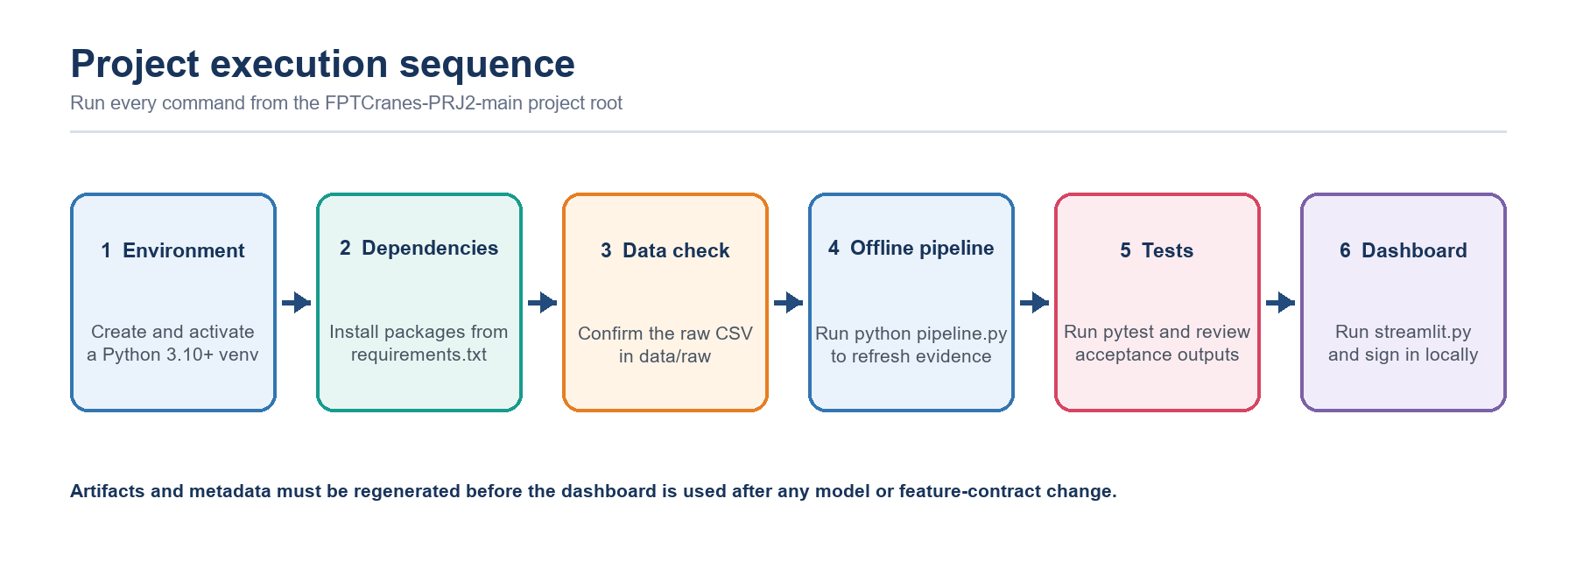
Figure 20. Recommended execution order from environment setup to the authenticated Streamlit dashboard.
E.1. Project folder structure:
FPTCranes-PRJ2-main/
├── data/raw/ai_jobs_market_2025_2026.csv
├── src/
│ ├── pipeline/ # 12-stage offline process
│ ├── training/ # preprocessing, temporal CV, ablation and tuning
│ ├── pages/ # Streamlit evidence and prediction pages
│ ├── components/ # authentication, navigation and shared UI
│ └── utils/ # artifact, insight and plotting helpers
├── outputs/
│ ├── 03_model_comparison/
│ ├── 04_best_model_and_feature_importance/
│ └── 05_salary_prediction/
├── artifacts/ # model bundle, metadata and contracts
├── config/project.yaml
├── tests/
├── pipeline.py # offline entry point
├── streamlit.py # dashboard entry point
└── requirements.txt

E.2. Prerequisites:
Requirement | Expected value | Verification
Python | 3.10 or later | python --version
Dependencies | pandas, numpy, matplotlib, scikit-learn, joblib, streamlit, pyyaml, pytest | python -m pip check
Raw data | data/raw/ai_jobs_market_2025_2026.csv | Confirm the file exists before training
Working directory | FPTCranes-PRJ2-main/ | pipeline.py and streamlit.py are visible

E.3. Step-by-step execution:
Step | Command | Expected result
1. Create environment | python -m venv .venv | Isolated Python environment created
2. Activate (Windows) | .venv\Scripts\activate | Virtual environment becomes active
2. Activate (macOS/Linux) | source .venv/bin/activate | Virtual environment becomes active
3. Install | python -m pip install -r requirements.txt | Required packages installed
4. Run pipeline | python pipeline.py | Stages 1–12 refresh outputs, artifacts and metadata
5. Run tests | python -m pytest -q | Automated project-contract checks complete
6. Launch dashboard | streamlit run streamlit.py | Local dashboard opens at http://localhost:8501

After launch, use the local demonstration account admin / AIJob2026! for the full evidence view or user / user123 for the simplified candidate view. Replace these credentials before any shared deployment.
E.4. Troubleshooting:
Error or symptom | Likely cause | Corrective action
Raw dataset not found | CSV is absent or the command is run from the wrong directory | Place the file in data/raw and run from the project root
ModuleNotFoundError | Dependencies are not installed in the active environment | Activate .venv and reinstall requirements.txt
Stage 09 outputs are missing | The offline pipeline has not completed | Run python pipeline.py and inspect the terminal log
Deployment artifacts are missing | model_bundle.joblib or metadata.json was not generated | Re-run the pipeline before Streamlit
Login fails | Credential mismatch or environment override | Check case, demo values and AI_JOB_USER / AI_JOB_PASSWORD
City-country validation error | The pair violates the deployment-gate map | Select a supported logical pair before adding to the queue

Operational rule: after changing the model, preprocessing or feature contract, do not reuse an older Streamlit session. Regenerate artifacts, restart the application and confirm bundle equivalence first.

F - CONCLUSION AND FUTURE DEVELOPMENT

F.1 | Data Basic Clean  A null-free dataset was not accepted at face value; logic and categorical corruption were audited.

1500  Raw rows | 25  Raw columns | 0  Missing cells | 0  Duplicates

Basic structural checks found 0 missing cells and 0 duplicate rows. However, the categorical sanity check identified one corrupted row in the source field 'AI Engineering': the literal header value 'job_category' appeared as a record value. That row was removed and the field was canonically renamed to job_category, producing 1,499 clean records.
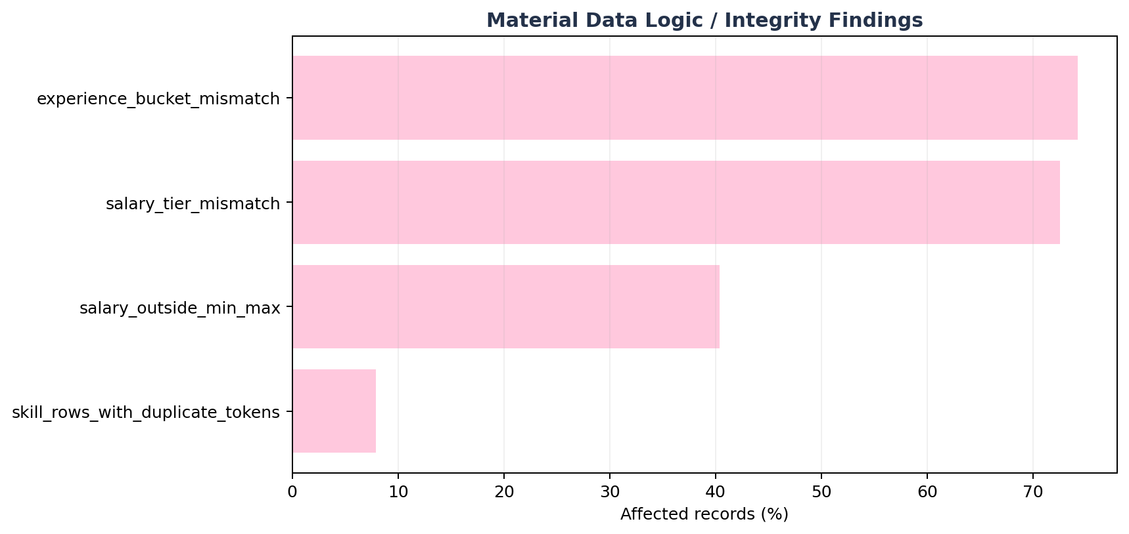
Figure 1. Share of clean rows affected by major logic/integrity findings.

issue | affected_rows | affected_pct | action
experience_bucket_mismatch | 1113 | 74.2% | Drop experience_level from primary model; retain years_of_experience as an ablation-sensitive numeric feature.
salary_outside_min_max | 605 | 40.4% | Block salary_min_usd and salary_max_usd from X.
salary_tier_mismatch | 1,087 | 72.5% | Block salary_tier from X.
skill_rows_with_duplicate_tokens | 118 | 7.9% | De-duplicate skill tokens within each row before multi-hot encoding.

Conclusion – Data basic clean Structural cleanliness alone would have been misleading. The cleaned output is suitable for controlled modeling only after blocking inconsistent target-adjacent fields and explicitly treating experience semantics as a synthetic-risk warning.

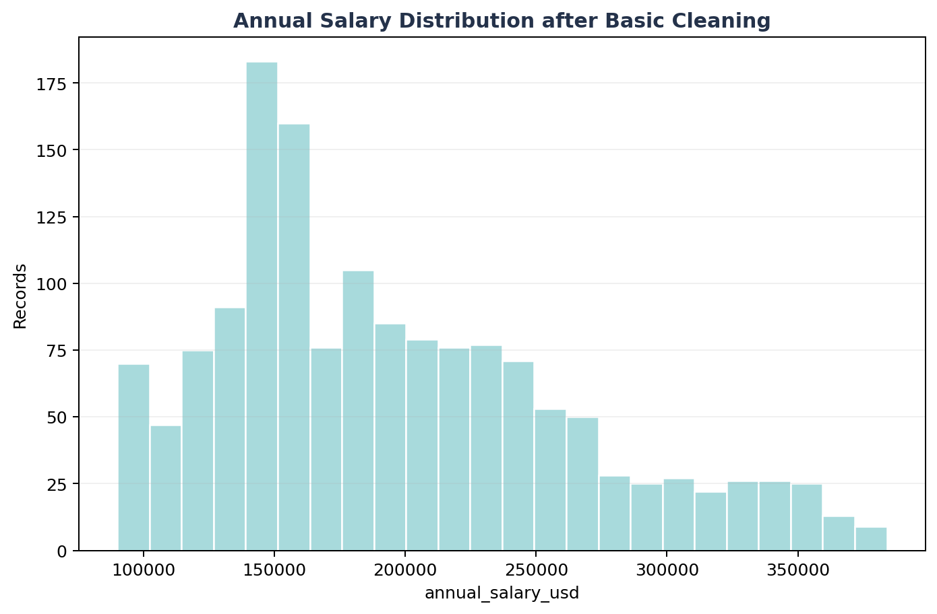
Figure 2. Target distribution after basic cleaning.

F.2 | Data Ready for Machine Learning  Leakage gate, temporal split, TRAIN-only encoding/scaling, multi-hot skills and skill_count.

1,201  TRAIN / DEV | 298  Locked Test | 93  Skill vocabulary | 189  Encoded features

The model input retains the technical design's 11 structured predictors and adds a skill-aware Phase-2 enhancement: required_skills is normalized into distinct pipe-separated tokens, multi-hot encoded by a vocabulary learned only from TRAIN/DEV, and accompanied by skill_count (distinct token count). In this supplied snapshot the TRAIN vocabulary contains 93 tokens.
Allowed model inputs:
feature | role
job_title | KEEP
job_category | KEEP
years_of_experience | KEEP
education_required | KEEP
city | KEEP
country | KEEP
remote_work | KEEP
company_size | KEEP
industry | KEEP
demand_score | KEEP
benefits_score_10 | KEEP
required_skills | PHASE2_MULTI_HOT
skill_count | ENGINEERED

Blocked fields include identifiers, target-adjacent salary metadata, contradictory/redundant experience flags, and non-serving metadata. This protects the model from learning the answer directly or from unstable derived signals.
feature | reason
job_id | Identifier, redundant/contradictory, derived flag, or non-serving metadata
salary_min_usd | Target leakage / target-adjacent
salary_max_usd | Target leakage / target-adjacent
salary_tier | Target leakage / target-adjacent
experience_level | Identifier, redundant/contradictory, derived flag, or non-serving metadata
posting_year | Identifier, redundant/contradictory, derived flag, or non-serving metadata
posting_month | Identifier, redundant/contradictory, derived flag, or non-serving metadata
is_senior | Identifier, redundant/contradictory, derived flag, or non-serving metadata
is_remote_friendly | Identifier, redundant/contradictory, derived flag, or non-serving metadata
is_llm_role | Identifier, redundant/contradictory, derived flag, or non-serving metadata
ai_salary_premium_pct | Identifier, redundant/contradictory, derived flag, or non-serving metadata
demand_growth_yoy_pct | Identifier, redundant/contradictory, derived flag, or non-serving metadata

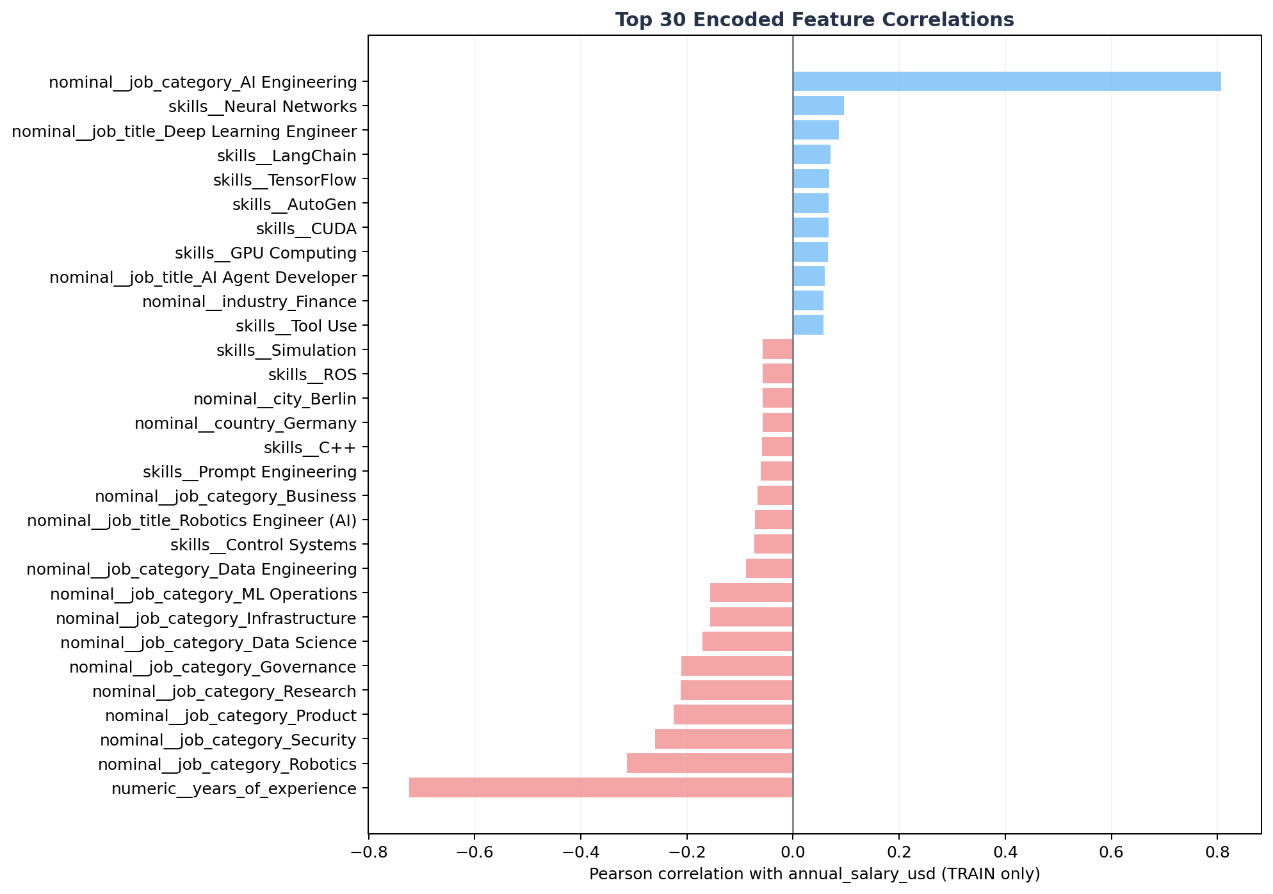
Figure 3. Top 30 TRAIN-only encoded correlations with annual_salary_usd.
Conclusion – Data ready for ML The encoded dataset is ready for modeling with 189 numeric columns. The strongest TRAIN-only encoded correlation is nominal__job_category_AI Engineering (r=+0.807); this is diagnostic association, not causal evidence.

F.3 | Model Comparison  Leakage-safe comparison on identical expanding monthly validation folds.

Purpose of Stage 9: compare the approved regression families under the same out-of-time validation design and select the model family before opening the March 2026 locked test.
Random Forest  Selected family | $12,594  Mean CV MAE | 0.878  Mean CV R² | 5  Temporal folds

Comparison evidence:
Rank | Candidate | Mean MAE | MAE SD | Mean R² | Decision
1 | Random Forest | $12,594 | $2,887 | 0.878 | Selected
2 | Gradient Boosting | $14,408 | $1,498 | 0.853 | Strong challenger
3 | Ridge Regression | $25,489 | $3,220 | 0.718 | Not selected
4 | Linear Regression | $28,827 | $3,380 | 0.658 | Not selected
5 | Dummy Median | $54,177 | $5,071 | −0.058 | Reference floor


Figure 4. Mean temporal-CV MAE across the approved candidates; lower values are better.
Evaluation: Random Forest reduces mean MAE by 12.6% relative to Gradient Boosting and by 76.8% relative to the Dummy Median floor. The same five folds and the same TRAIN-only preprocessing are used for every candidate, so the comparison isolates model-family performance rather than split or preprocessing differences.
Conclusion – Model comparison Random Forest provides the strongest aggregate out-of-time accuracy and proceeds to bounded tuning. The selection is made without consulting the locked test; runtime is acceptable for all serious candidates and is therefore not the deciding factor.
F.4 | Best Model Selection and Feature Importance Review  One-time locked-test evaluation with residual-tail and feature-reliance diagnostics.

Random Forest  Best model | $15,005  Locked MAE | $29,819  Locked RMSE | 0.803  Locked R² | $4,354  Locked MedAE

Purpose of Stage 10: tune the selected family inside the development period, evaluate the frozen configuration once on 298 future records and determine whether its errors and reliance evidence support the intended academic use.

Figure 5. Actual versus predicted annual salary for the 298 locked-test records.


Figure 6. Encoded impurity importance and raw-feature permutation importance show complementary forms of model reliance.
Evaluation question | Evidence | Assessment
Does the model generalize out of time? | $15,005 MAE and 0.803 R²; MAE is 20.8% above tuning CV. | Predictive value remains, with measurable temporal degradation.
Is the error uniform? | $4,354 MedAE versus $29,819 RMSE. | Most errors are modest, but a smaller tail of large misses drives RMSE.
What drives the model? | job_category and years_of_experience dominate both reliance diagnostics. | Interpret as model behavior, not causality or a salary rule.
Does high importance mean high accuracy? | AI Engineering: 156 records and MAE ≈ $26,319. | No. A heterogeneous, influential category can still contain the largest errors.
How is uncertainty communicated? | Empirical validation-error half-width: ±$32,028. | Useful warning band, not a formal confidence interval.

Conclusion – Best model and feature importance The frozen Random Forest is suitable for academic benchmarking and controlled scenario exploration. Its typical error is much smaller than its tail-sensitive error, and the AI Engineering result demonstrates that importance measures reliance—not reliability, balance or causal effect.

F.5 | AI Market Job Salary Prediction  One saved pipeline, a metadata-driven Streamlit contract and an explicit practical error band.

298  Locked-test rows | $197,695  Mean prediction | $194,612  Median prediction | ±$32,028  Practical half-width

Purpose of Stages 11 and 12: serve the exact preprocessing-plus-model bundle evaluated offline, validate the ordered 13-field input contract and return each point estimate with an empirical error band and scientific-use warning.

Figure 7. Saved-bundle serving contract from raw inputs to the point estimate and practical error band.
Contract item | Implementation evidence | Why it matters
Single fitted bundle | Preprocessor and Random Forest serialized together | Reduces training-serving skew
Metadata-driven form | 13 ordered raw fields, categories, ranges and 93 skills | Keeps the interface aligned with training
Artifact verification | Reloaded predictions match; max_abs_diff = 0 | Confirms serialization equivalence
Practical bounds | max(0, prediction − $32,028) to prediction + $32,028 | Shows observed validation uncertainty


Figure 8. Role-aware entry, logical validation, queue construction, batch inference and CSV export.
Representative locked-test predictions:
Job title | Category | Location | Actual | Predicted | Absolute error
AI Compliance Manager | Security | Zurich, Switzerland | $90,000 | $91,846 | $1,846
AI Solutions Architect | AI Engineering | Boston, USA | $287,000 | $258,447 | $28,553
AI Solutions Architect | AI Engineering | Toronto, Canada | $360,000 | $264,284 | $95,716
ML Engineer | AI Engineering | Paris, France | $360,000 | $194,552 | $165,448

Interpretation: the examples deliberately show both small and large errors. Two AI Engineering cases exceed the ±$32,028 practical band, reinforcing that the band summarizes held-out absolute error rather than guaranteeing coverage for every record.
Future development priorities:
Priority | Next development step | Acceptance evidence
External validity | Evaluate later, independently sourced job postings and preserve temporal ordering. | Report MAE, RMSE and R² by month, category and country before operational use.
Uncertainty quality | Replace the fixed global band with calibrated, subgroup-aware prediction intervals. | Publish empirical coverage and interval width on untouched data.
Deployment governance | Add managed secrets, artifact versioning, audit logs and drift/retraining triggers. | Produce traceable releases and reviewed alerts rather than silent model changes.

Conclusion – Salary prediction The dashboard implements the same metadata-controlled inference contract as the offline pipeline, including logical input validation, queued batch prediction, downloadable evidence and uncertainty communication. It is appropriate for academic demonstration, but external validation, monitoring, stronger authentication and broader market data are required before operational compensation decisions.

G - REFERENCES
- eBook
- eBook
- eBook
- eBook

H - TASK ASSIGNMENT TABLE
TASK ASSIGNMENT TABLE
No. | Main task | Student name | Completion - %
1 | Load data & Data Quality Check | Gia Bảo
2 | Contradictory-Feature Investigation, Feature Selection & Correlation Analysis | Nguyễn Kim Ngân
3 | Encoding, Scaling, Feature Engineer, and Leakage Prevention | Duy AI
4 | Model Training & Comparison, Best Model Selection and Feature Importance Review | Huỳnh Minh
5 | Streamlit Salary Prediction Dashboard & Visualization | Tạ Gia Hiển

STAGE | NGƯỜI PHỤ TRÁCH | GHI CHÚ
1. Load Data | Bảo | Sau bước này có data cơ bản clean
2. Project Scope & Initial Inspection | Bảo
3. Data Quality Check | Bảo
4. Corrupted Row Removal | Bảo
5. Contradictory-Feature Investigation | Ngân | Sau bước này có data ready cho train model
6. Feature Selection & Leakage Preventaion | Ngân & Duy AI
7. Correlation Encoding & Analysis | Duy AI
8. Train-Test Split | Minh | Sau bước này chọn được model và tính năng quan trọng
9. Model Training & Comparison | Minh
10. Best Model Selection & Feature Importance Review | Minh
11. Save Deployable Pipeline + Metadata | Hiển | Đây là module dựng dự đoán lương cho tương lai khi nhập thông tin vào feature X
12. Streamlit Salary Prediction Dashboard | Hiển

- Data Dictionary and Modeling Role – before cleaning:
Source column | dtype | Observed domain | Role | Policy | Technical note
job_id | object | 1500 unique | ID | BLOCK | Identifier; suffix is strongly ordered with salary.
job_title | object | 25 unique | Nominal | KEEP | Core role feature; 25 categories.
job_category (old name = AI Engineering) | object | 13 unique | Nominal | KEEP after cleaning | Canonical rename to job_category; remove invalid row value "job_category".
experience_level | object | 4 unique | Ordinal/category | ABLATION | Semantically inconsistent with years_of_experience; do not trust blindly.
years_of_experience | int64 | 1 .. 15; 15 unique | Numeric | ABLATION | Strong predictive signal but implausible downward salary relationship; production promotion requires provenance.
education_required | object | 5 unique | Ordinal | KEEP | Explicit ordered encoder; unknown categories -> -1 or dedicated Unknown.
annual_salary_usd | int64 | 90000 .. 384000; 248 unique | Target | TARGET | Regression target only.
salary_min_usd | int64 | 90000 .. 180000; 17 unique | Target-adjacent | BLOCK primary | Fixed by job_title and annual salary lies outside stated range in 40.3% of rows.
salary_max_usd | int64 | 180000 .. 320000; 16 unique | Target-adjacent | BLOCK primary | Fixed by job_title; logically inconsistent with target for many rows.
city | object | 20 unique | Nominal | KEEP/ABLATE | 20 values; deterministically maps to country in this snapshot.
country | object | 14 unique | Nominal | KEEP/ABLATE | 14 values; redundant with city for current snapshot.
remote_work | object | 3 unique | Nominal | KEEP | 3 categories.
company_size | object | 5 unique | Nominal | KEEP | 5 categories.
industry | object | 12 unique | Nominal | KEEP | 12 categories.
required_skills | object | 1500 unique | Multi-label text | PHASE 2 | Raw string is unique in all 1,500 rows; tokenize by | into train-only vocabulary (93 observed tokens).
ai_salary_premium_pct | float64 | 3 .. 18; 151 unique | Numeric | CONDITIONAL | Use only if provenance confirms it is available before target and not computed from compensation.
demand_score | int64 | 68 .. 98; 20 unique | Numeric | KEEP/ABLATE | 20 values; exact function of job_title in this snapshot, so it adds no independent information if title is present.
demand_growth_yoy_pct | float64 | 5 .. 87.8; 565 unique | Numeric | CONDITIONAL | Availability/provenance gate; excluded from conservative baseline.
benefits_score_10 | int64 | 6 .. 10; 5 unique | Numeric | KEEP | Observed range 6-10.
posting_year | int64 | 2025 .. 2026; 2 unique | Temporal | SPLIT / CONDITIONAL X | Required for temporal split; use as feature only if deployment date is known and ablation supports it.
posting_month | int64 | 1 .. 12; 12 unique | Temporal | SPLIT / CONDITIONAL X | Same as posting_year; avoid full-dataset temporal preprocessing.
is_senior | int64 | 0 .. 1; 2 unique | Derived flag | BLOCK primary | Exact deterministic derivative of experience_level in supplied data.
is_remote_friendly | int64 | 0 .. 1; 2 unique | Derived flag | BLOCK primary | Exact deterministic derivative of remote_work in supplied data.
is_llm_role | int64 | 0 .. 1; 2 unique | Derived flag | BLOCK primary | Deterministic by job_title in supplied data; redundant if job_title is present.
salary_tier | object | 5 unique | Target-adjacent | BLOCK primary | Only 27.5% consistent with annual_salary_usd band; not safe as predictor or evaluation label.

